**UNIVERSIDAD LAICA ELOY ALFARO DE MANABI**

**FACULATD DE CIENCIAS INFORMATICAS**

**CARRERA DE TECNOLOGIA DE LA INFORMACION**

**TRABAJO AUTÓNOMO MAQUETACIÓN PÁGINAS WEB**

**INTEGRANTES:**

• ARTEAGA ZAMBRANO BRYAN DAVID.

• MACÍAS PICO JOSSELYN STEFANY.

• RIVERA ALVARADO ROSA GUADALUPE.

• VILLAMAR PILOSO DAYANA LISSETH.

**ASIGNATURA:**

INGENIERIA DE SOFTWARE I

**CURSO:**

QUINTO “B”

**DOCENTE:**

ING(A) PATRICIA ALEXANDRA QUIROZ PALMA

**PERIODO:**

2020(2)

**MANTA – MANABI – ECUADOR**

Índice

1. PROPÓSITO DEL DOCUMENTO 4

2. DESCRIPCIÓN DEL NEGOCIO 4

3. DESCRIPCIÓN TEXTUAL 4

4. GRAFICO DE LOS NODOS DE LA PAGINA WEB(DOM) 7

5. CODIGO DE HTML, CSS, JAVASCRIPT 30

Estilos CSS 31

Entrada 32

Informe 33

Inicio 42

Loguin 46

*Ingreso 46

*Registro 48

Usuario 51

*Editar Usuario 51

*Nuevo Producto 54

*Usuario 57

Productos 63

*Editar producto 63

*Nuevo Producto 68

*Productos 71

Proveedores 77

*Evitar Proveedor 77

*Nuevo proveedor 80

*Proveedores 81

Salida de producto 86

Stock 88

6. EVIDENCIA 91

Evidencia1(Registro) 91

Evidencia 2(Iniciar Sesión) 91

Evidencia 3(Inicio) 92

Evidencia 4(Acceso Rápido: Nuevo usuario) **Error! Bookmark not defined.**

Evidencia 5(Acceso Rápido: Nuevo producto) **Error! Bookmark not defined.**

Evidencia 6(Acceso Rápido: Nuevo proveedor) **Error! Bookmark not defined.**

Evidencia 7(Usuario) 93

Evidencia 8(Nuevo usuario) 94

Evidencia 9(Eliminar usuario) 95

Evidencia 10(Editar usuario) 95

Evidencia 11(Lista de Productos) 96

Evidencia 12(Nuevo Producto) 97

Evidencia 13(Eliminar Producto) 98

Evidencia 14(Editar Producto) 98

Evidencia 15(Lista de proveedores) 99

Evidencia 16(Nuevo Proveedor) 100

Evidencia 17(Eliminar Proveedor) 100

Evidencia 18(Editar Proveedor) 101

Evidencia 19(Stock de productos) 101

Evidencia 20(Entrada de producto) 102

Evidencia 21(Salida de producto) 103

Evidencia 22(Movimientos: Informe de productos) 104

# PROPÓSITO DEL DOCUMENTO

El propósito del documento es poner en práctica los conocimientos requeridos acerca de HTML, CSS, JAVASCRIPT, por ende, se implementara un sistema que sirva para disminuir los problemas que tiene el mini-market identificando los requerimientos que se necesiten para el desarrollo del sistema.

# DESCRIPCIÓN DEL NEGOCIO

El proyecto de Ingeniería de Software está enfocado a contribuir con el crecimiento comercial de los pequeños negocios que están iniciando y que no cuentan con un sistema seguro y eficiente que les ayuden a administrar sus recursos, brindándole así las facilidades de que puedan tener un mejor control de su negocio. Este se desarrollará en un mini Marquet llamado THE TWINS ubicado en el barrio Altamira en la ciudad de Manta, encargado de abastecer de insumos de primera necesidad a la ciudadanía.

Para conocer los principales problemas que presenta el establecimiento fue necesario recurrir a dialogar con la dueña del mini Marquet, quien expreso algunos detalles defectuosos dentro de sus métodos de registro de inventario ya que se los realiza de manera manual por lo tanto no son fiables, así mismo nos dio a conocer que las inversiones que realizaba al adquirir sus productos y las ganancias obtenidas al final de cada jornada de trabajo no eran realmente buenas y exactas. Además, se destacó que no cuenta con un sistema de inventario que le muestre automáticamente todo lo que tiene en su negocio y así no contar con costos adicionales o insatisfacción en los clientes.

# DESCRIPCIÓN TEXTUAL

El software deberá diseñarse de manera que cumpla las siguientes necesidades:

* Registrar usuario.
* Editar registro del usuario.
* Ver estado del usuario.
* Eliminar registro de usuario.
* Enlistar usuarios.
* Registrar producto.
* Editar registro del producto.
* Eliminar registro de producto.
* Enlistar producto.
* Registrar proveedor.
* Editar registro del proveedor.
* Ver estado del proveedor.
* Eliminar registro de proveedor.
* Enlistar proveedor.
* Entrada de producto (stock).
* Salida de producto (stock).

Las tareas en base al sistema:

* **Registrar** **usuario**.

El sistema del control de inventario debe permitir el registro de los usuarios (empleado/administrador) al sistema.

* **Enlistar usuario.**

El sistema del control de inventario debe permitir enlistar el registro de los usuarios del mini-market que se encuentran logueado en el sistema.

* **Modificar datos del usuario.**

El sistema del control de inventario debe permitir modificar datos de los usuarios registrados en el sistema.

* **Eliminar usuario.**

El sistema del control de inventario debe permitir eliminar cualquier usuario que se encuentre registrado.

* **Ver el estado del usuario.**

El sistema del control de inventario debe permitir visualizar el estado (activo) de cualquier usuario que se encuentre registrado.

* **Registrar** **producto**.

El sistema del control de inventario debe permitir el registro de los productos al sistema.

* **Enlistar producto.**

El sistema del control de inventario debe permitir enlistar los productos que se encuentran registrados en el sistema.

* **Modificar datos del producto.**

El sistema del control de inventario debe permitir modificar datos de los productos registrados en el sistema.

* **Eliminar producto.**

El sistema del control de inventario debe permitir eliminar cualquier producto que se encuentre registrado.

* **Registrar** **proveedor**.

El sistema del control de inventario debe permitir el registro de los proveedores al sistema.

* **Enlistar proveedor.**

El sistema del control de inventario debe permitir enlistar los proveedores que se encuentran registrados en el sistema.

* **Modificar datos del proveedor.**

El sistema del control de inventario debe permitir modificar datos de los proveedores registrados en el sistema.

* **Eliminar proveedor.**

El sistema del control de inventario debe permitir eliminar cualquier proveedor que se encuentre registrado.

* **Mostrar el stock.**

El sistema debe permitir mostrar el stock de los productos que tiene registrado en la base de datos.

* **Actualizar stock.**

El sistema deberá mantener actualizaciones constantemente de todos los productos que se encuentran dentro de la base de datos.

* **Control de movimientos: entrada/salida productos.**

El sistema debe permitir la entrada y salida de todos los productos que se compren o vendan.

# GRAFICO DE LOS NODOS DE LA PAGINA WEB(DOM)

* 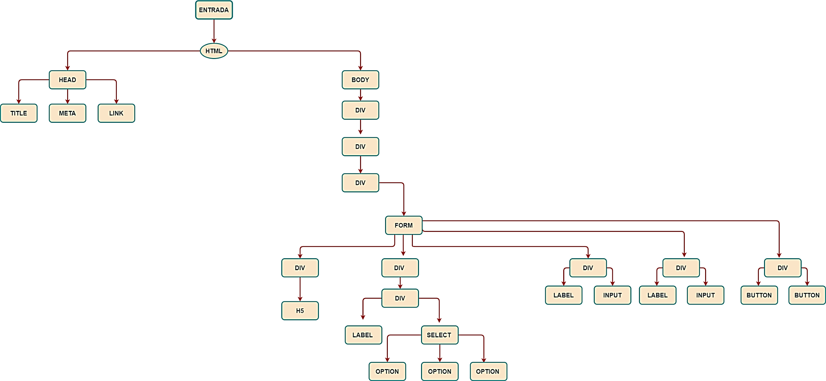**Nodo de Entrada de Productos**
* 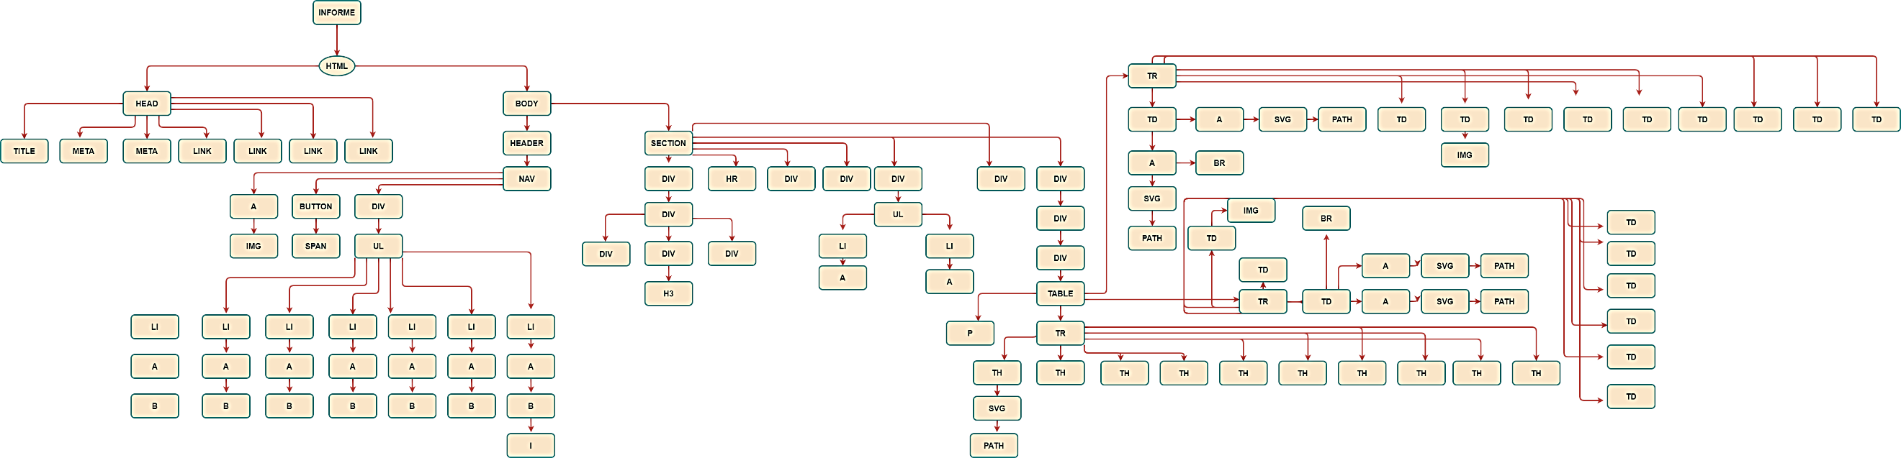**Nodo del informe de entradas y salidas de productos**



* 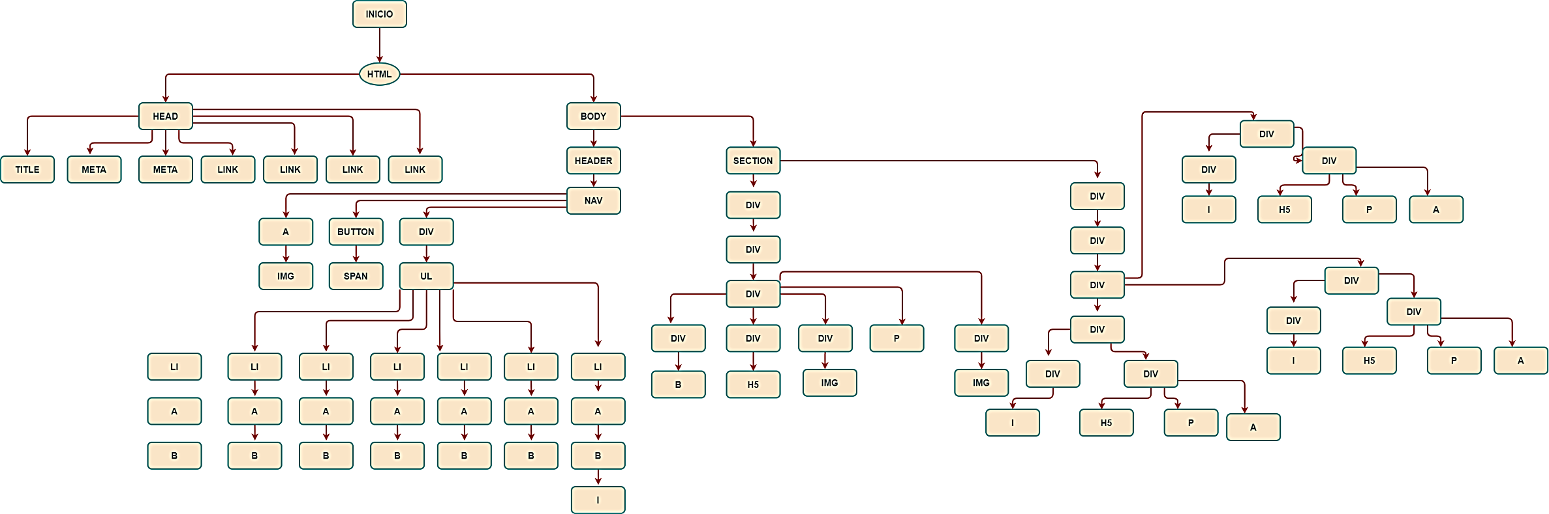**Nodo del Inicio**
* 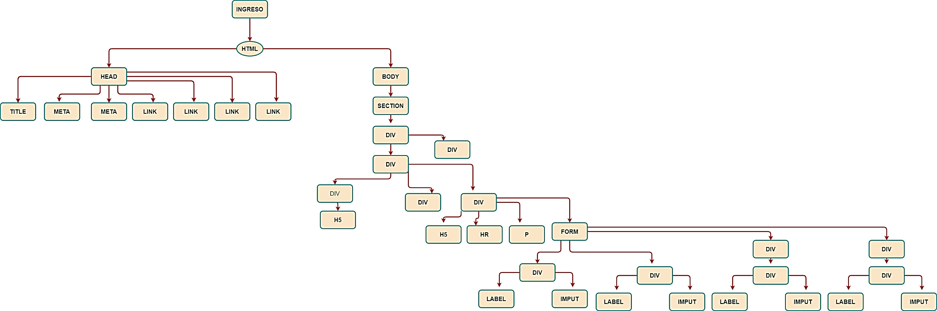**Nodo de Ingreso**
* 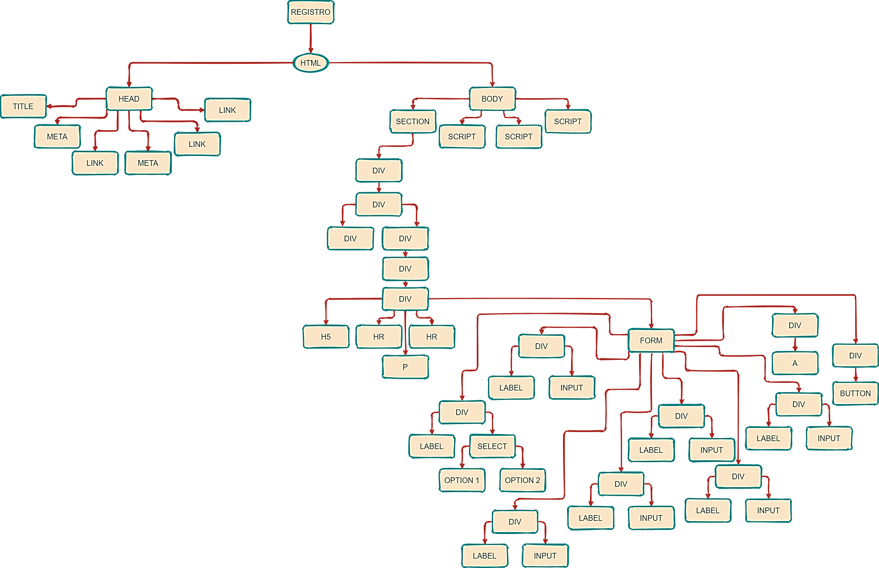**Nodo del Registro**
* 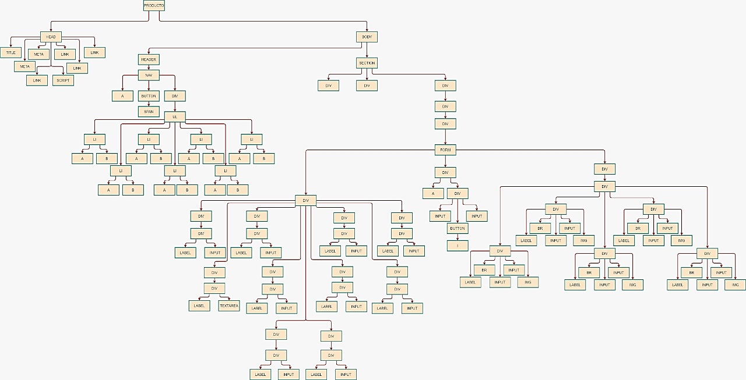**Nodo de Editar producto**
* 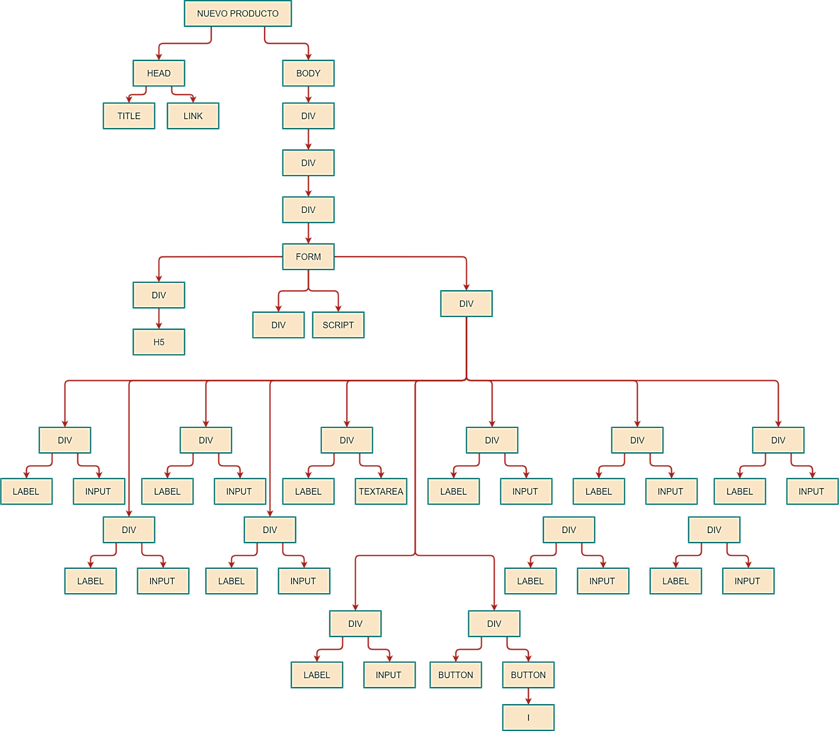**Nodo de Nuevo Producto**
* 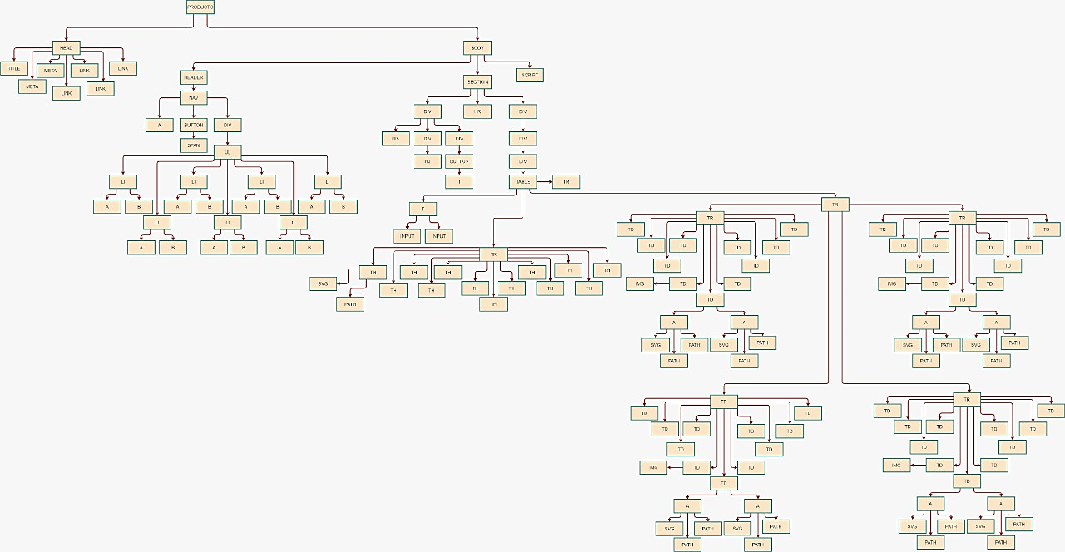**Nodo de Producto**



* **Nodo de Editar proveedor**

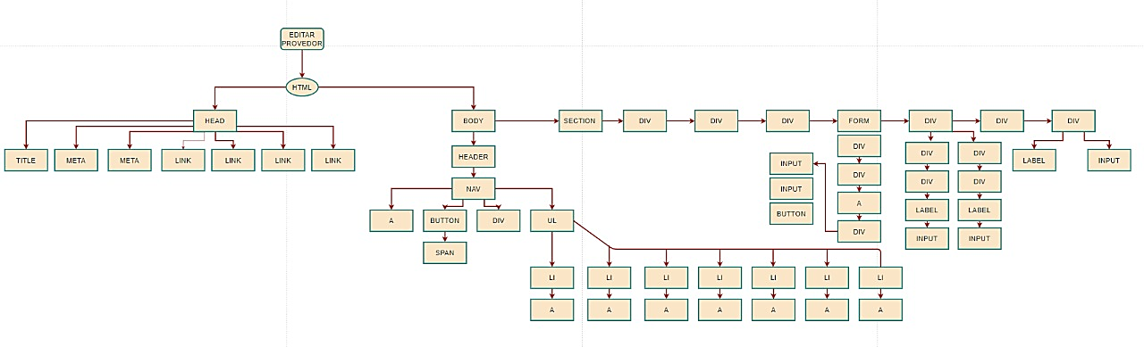



* 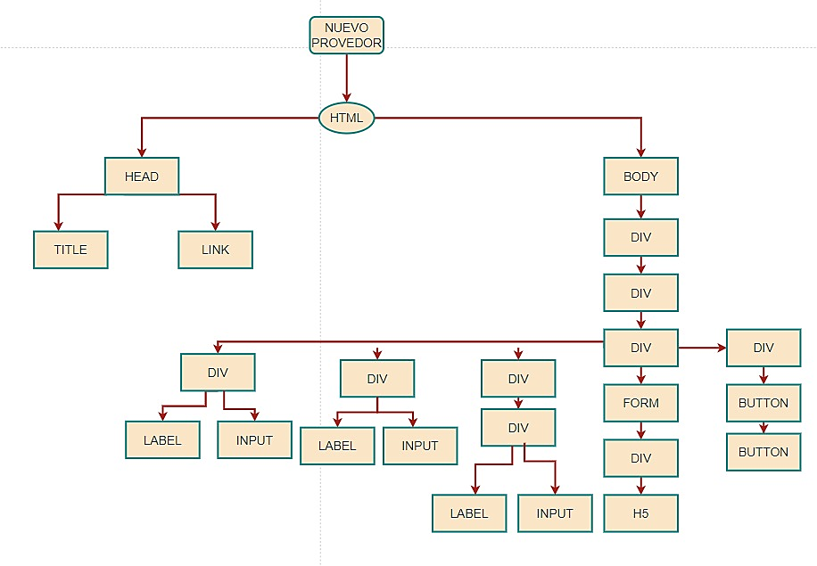**Nodo de Nuevo proveedor**
* 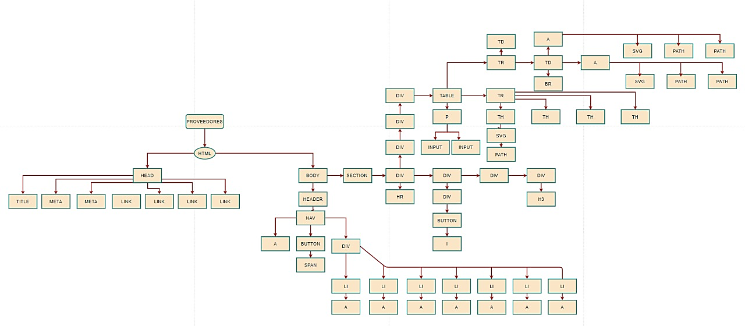**Nodo de proveedor**
* 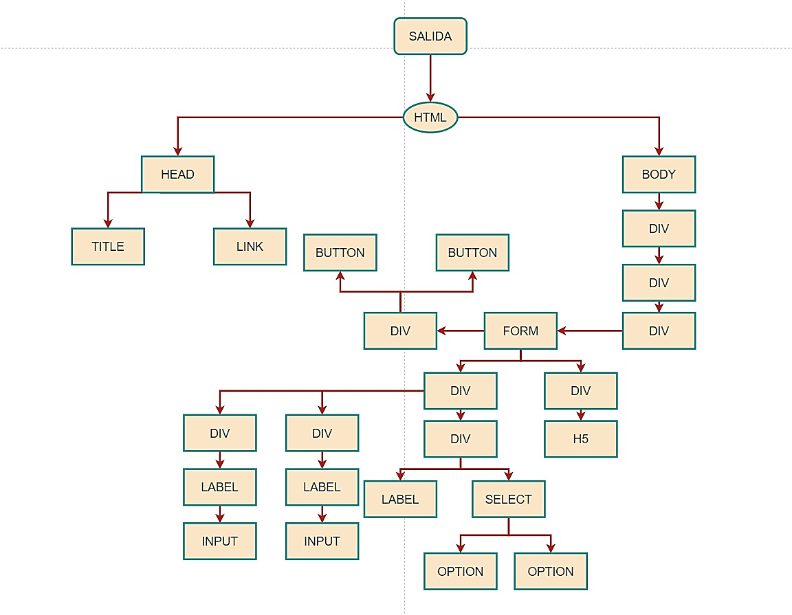**Nodo de salida de productos**
* 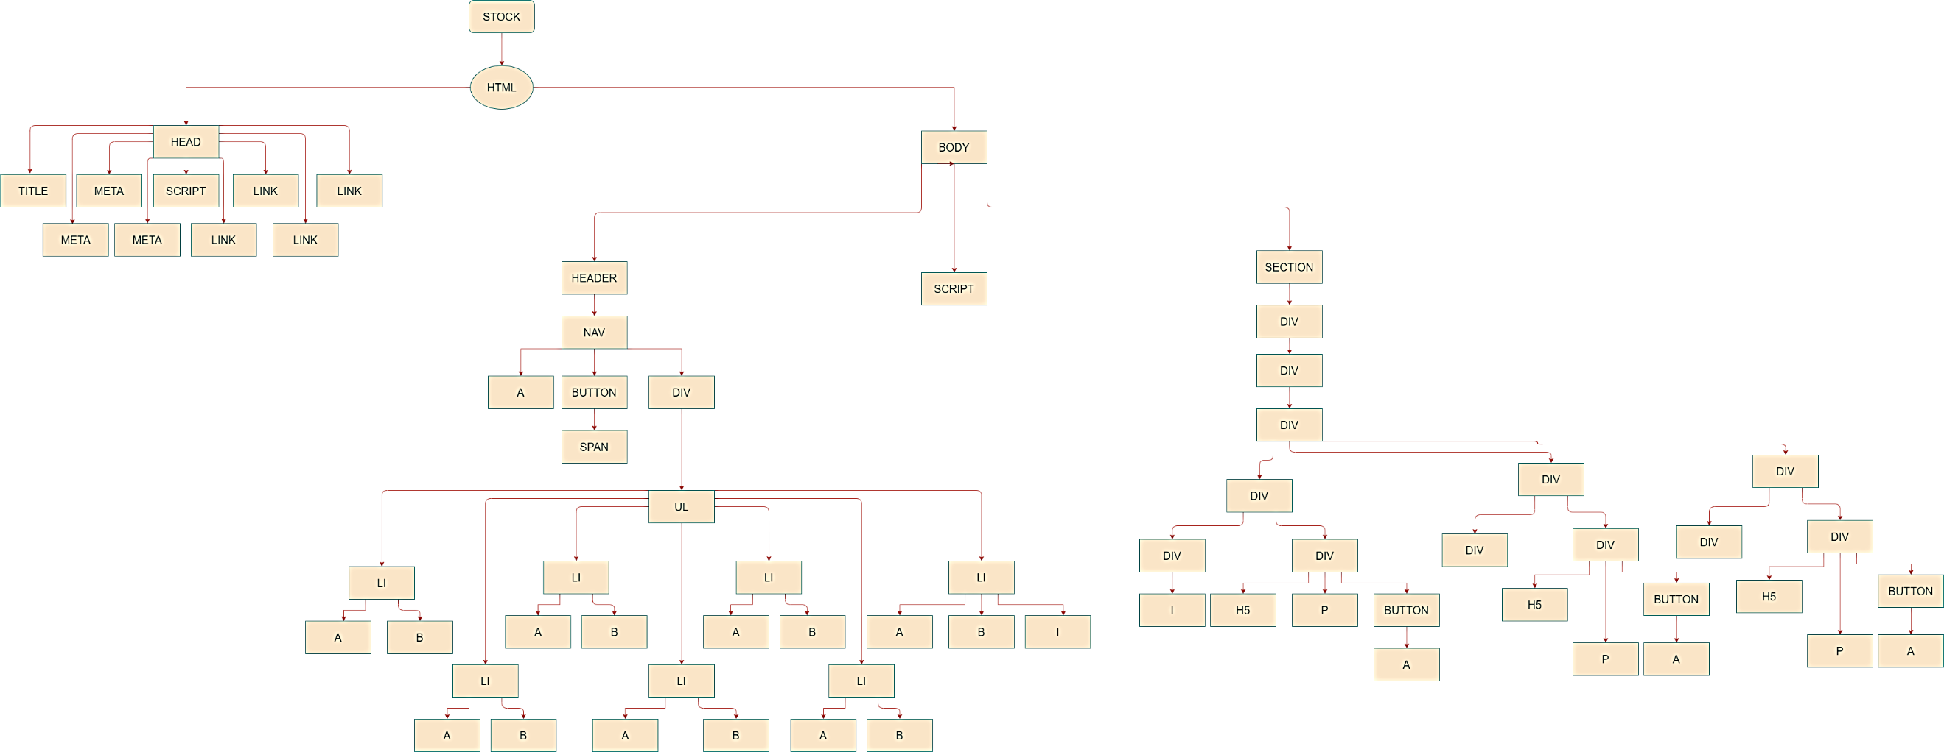**Nodo de Stock**



* 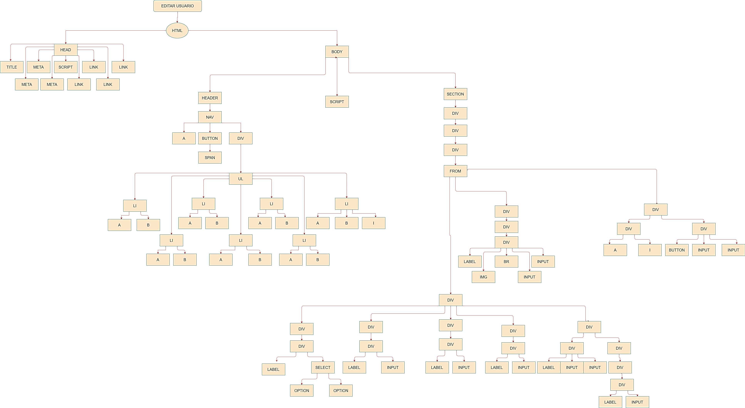**Nodo de Editar usuario**
* 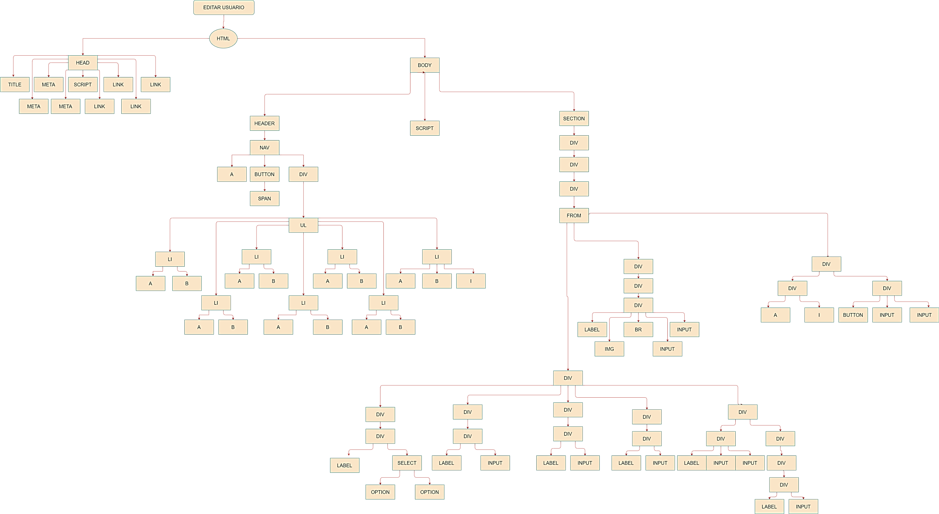
* 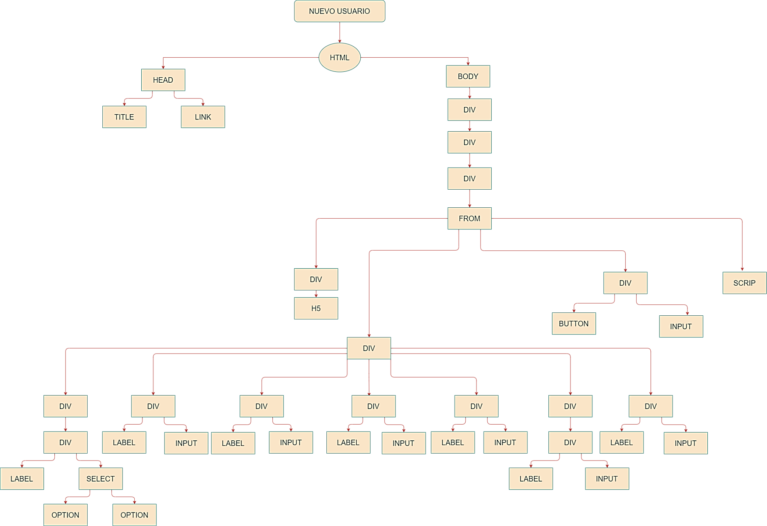**Nodo de Nuevo usuario**
* **Nodo de Usuario**

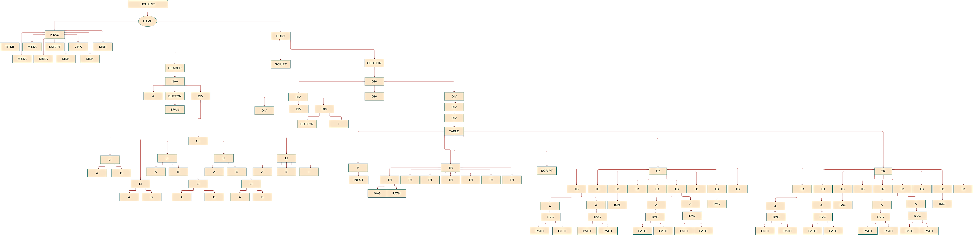

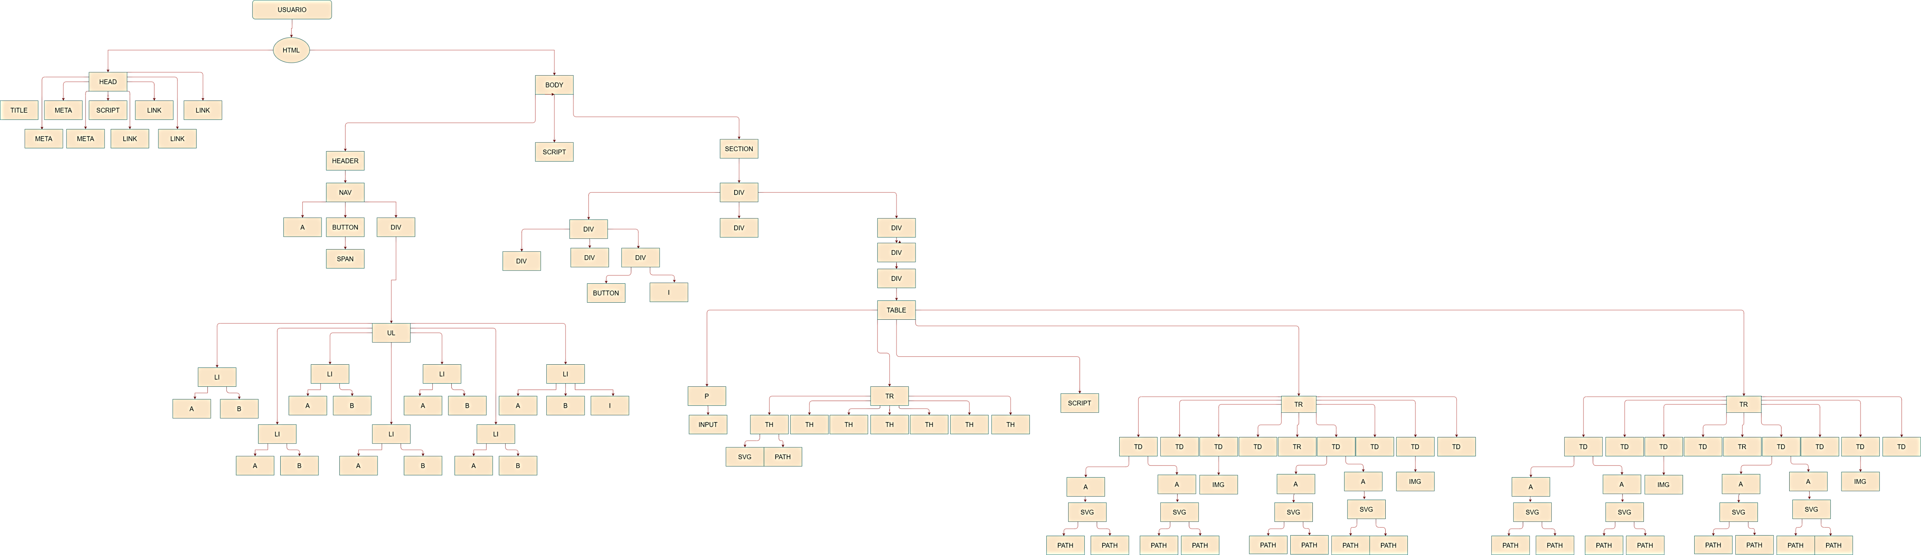

# 



# CODIGO DE HTML, CSS, JAVASCRIPT

## Estilos CSS

body{

    text-align: center;

    font size: 16px;

}

* {

    box-sizing: border-box;

}

 form {

    padding: 1em;

    background: #f9f9f9;

    border: 1px solid #c1c1c1;

    margin-top: 2rem;

    max-width: 600px;

    margin-left: auto;

    margin-right: auto;

    padding: 1em;

    font-size:17px;

  }

form button {

    background: lightgrey;

    padding: 0.7em;

    border: 0;

}

form button:hover {

    background: gold;

}

label {

    text-align: left;

    display: block;

    padding: 0.5em 1.5em 0.5em 0;

}

input {

    width: 100%;

    padding: 0.7em;

    margin-bottom: 0.5rem;

}

input:focus {

    outline: 3px solid gold;

}

form-control{

}

## Entrada

<!DOCTYPE html>

<html>

<head>

  <title>Entrada productos</title>

  <link rel="stylesheet" type="text/css" href="../css/stilos.css">

</head>

<body>

  <div class="modal fade" id="entrada" tabindex="-1" aria-labelledby="nuevoLabel" aria-hidden="true">

    <div class="modal-dialog">

      <div class="modal-content">

          <form method="POST" action="../stock/stock.html" enctype="multipart/form-data">

            <div class="modal-header">

              <h5 class="modal-title" id="nuevoLabel">Nueva Entrada de Productos</h5>

            </div>

            <div class="modal-body">

              <div class="form-group">

                <label for="exampleInputEmail1">Nombres</label>

                <select class="form-control" id="nombre_entrada" name="id_prod">

                    <option>Leche</option>

                    <option>Arroz</option>

                    <option>Lenteja </option>

                </select>

              </div>

              <div class="form-group">

                <label for="exampleInputEmail1">Cantidad</label>

                <input type="number" step="1" id="cant_entrada" min="1" class="form-control" name="cant_entrada" required="required">

              </div>

              <div class="form-group">

                <label for="exampleInputEmail1">Fecha</label>

                <input type="date" id="fecha_entrada" class="form-control" name="fecha_entrada" required="required">

              </div>

            </div>

            <div class="modal-footer">

              <button onclick="window.close();" type="button" class="btn btn-secondary" data-dismiss="modal">Close</button>

              <button onclick="entradaproducto();"type="submit" name="entrada" class="btn btn-primary">Guardar <i class="fas fa-save"></i></button>

            </div>

             <script type="text/javascript">

               function entradaproducto(){

                       name_e=document.getElementById('nombre_entrada').value;

                       cant_e=document.getElementById('cant_entrada').value;

                       fecha_e=document.getElementById('fecha_entrada').value;

                      if (name_e==null || name_e.length ==0) {

                        alert("Algunos campos estan vacios");

                        return false;

                      }

                      if (cant_e==null || cant_e.length ==0) {

                        alert("Algunos campos estan vacios");

                        return false;

                      }

                      if (cant_e<1) {

                        alert("La cantidad del producto debe ser mayor a 1 ");

                        return false;

                      }

                      if (fecha_e==null || fecha_e.length ==0) {

                        alert("Algunos campos estan vacios");

                        return false;

                      }

                      alert("El producto comprado ha sido agregado")

                      window.close();

                      return true;

                    }

            </script>

          </form>

      </div>

    </div>

  </div>

</body>

</html>

## Informe

<!DOCTYPE html>

<html lang="es">

<head>

    <title>Informe</title>

    <meta charset="UTF-8">

    <meta name="viewport" content="width=device-width, initial-scale=1.0">

    <link rel="icon" type="imagen/png" href="favicon.ico">

    <link rel="stylesheet" href="https://stackpath.bootstrapcdn.com/bootstrap/4.5.2/css/bootstrap.min.css" integrity="sha384-JcKb8q3iqJ61gNV9KGb8thSsNjpSL0n8PARn9HuZOnIxN0hoP+VmmDGMN5t9UJ0Z" crossorigin="anonymous">

    <link rel="stylesheet" type="text/css" href="style.css">

    <link rel="stylesheet" type="text/css" href="//cdn.datatables.net/1.10.21/css/jquery.dataTables.min.css">

    <script type="text/javascript" src="https://sistemasongoku.com/plugins/ckeditor/ckeditor.js"></script>

</head>

<body>

    <header>

        <nav class="navbar navbar-expand-lg " style="background-color: #C2D1F0

; color: black !important;">

            <a style=  "margin-left: 62px" class="navbar-brand" href="<?= HOME; ?>"> <img src="../imagen/logo.png"  style="max-width: 120px;"></a>

            <button class="navbar-toggler" type="button" data-toggle="collapse" data-target="#navbarColor02" aria-controls="navbarColor02" aria-expanded="false" aria-label="Toggle navigation">

                <span class="navbar-toggler-icon"></span>

            </button>

            <div class="collapse navbar-collapse" id="navbarColor02" style=  "margin-left: 90px">

                <ul class="navbar-nav mr-auto">

                    <li class="nav-item ">

                        <a class="nav-link h5.5" style=  "margin-left: 60px"  href="../inicio/inicio.html"><b>Inicio</b> </a>

                    </li>

                        <li class="nav-item ">

                            <a class="nav-link h5.5" href="../usuario/usuario.html"><b>Usuarios</b></a>

                        </li>

                    <li class="nav-item ">

                        <a class="nav-link h5.5" href="../Productos/productos.html"><b>Productos</b></a>

                    </li>

                    <li class="nav-item ">

                        <a class="nav-link h5.5" href="../proveedores/proveedores.html"><b>Proveedores</b></a>

                    </li>

                    <li class="nav-item ">

                        <a class="nav-link h5.5 " href="../stock/stock.html"><b>Stock Producto</b></a>

                    </li>

                    <li class="nav-item ">

                        <a class="nav-link h5.5"  href="../informes/informes.html"><b>Informes</b></a>

                    </li>

                    <li class="nav-item">

                        <a class="nav-link h5.5"  text-danger href="../login/registro.html"><b>Cerrar Session</b> <i class="fas fa-sign-out-alt"></i></a>

                    </li>

                </ul>

        </nav>

    </header>

    <section class="container pt-4 mt-4">

        <div class="container-fluid">

            <div class="row">

                <div class="col-sm-4"></div>

                <div class="col-sm-4 text-center">

                    <h3>Informe de productos</h3>

                </div>

                <div class="col-sm-4 text-right">

                </div>

            </div>

            <hr>

            <div class="row mb-4">

                <div class="col-lg-12 col-md-12 col-sm-12 col-xs-12 mb-4">

                    <div class="card card-primary card-tabs">

                        <div class="card-header p-0 pt-1">

                            <ul class="nav nav-tabs" id="myTab" role="tablist">

                                <li class="nav-item">

                                    <a class="nav-link active" id="home-tab" data-toggle="tab" href="#home" role="tab" aria-controls="home" aria-selected="true">Ingresos</a>

                                </li>

                                <li class="nav-item">

                                    <a class="nav-link" id="profile-tab" data-toggle="tab" href="#profile" role="tab" aria-controls="profile" aria-selected="false">Salidas</a>

                                </li>

                            </ul>

                        </div>

                        <div class="card-body">

                            <div class="tab-content" id="custom-tabs-one-tabContent">

                                <div class="tab-pane active" id="home" role="tabpanel" aria-labelledby="home-tab">

                                    <div id="div1" class="col-sm-12">

                                        <table id="example1" class="dataTable table table-bordered table-hover">

                                            <p align="right">

                                                <input type="search" name="busquedaproducto" placeholder="Buscar producto">

                                                <input type="submit" value="Buscar">

                                            </p>

                                            <tr>

                                                <th>

                                                    <svg xmlns="http://www.w3.org/2000/svg" width="16" height="16" fill="currentColor" class="bi bi-person-lines-fill" viewBox="0 0 16 16">

                                                    <path d="M6 8a3 3 0 1 0 0-6 3 3 0 0 0 0 6zm-5 6s-1 0-1-1 1-4 6-4 6 3 6 4-1 1-1 1H1zM11 3.5a.5.5 0 0 1 .5-.5h4a.5.5 0 0 1 0 1h-4a.5.5 0 0 1-.5-.5zm.5 2.5a.5.5 0 0 0 0 1h4a.5.5 0 0 0 0-1h-4zm2 3a.5.5 0 0 0 0 1h2a.5.5 0 0 0 0-1h-2zm0 3a.5.5 0 0 0 0 1h2a.5.5 0 0 0 0-1h-2z"/>

                                                    </svg>

                                                </th>

                                                <th>Id</th>

                                                <th>Foto</th>

                                                <th>Nombre</th>

                                                <th>Tipo de Producto</th>

                                                <th>Costo</th>

                                                <th>Cantidad Disponible</th>

                                                <th>Ingresaron</th>

                                                <th>Fecha de ingreso</th>

                                            </tr>

                                            <tr>

                                                <td>

                                                    <a onclick="eliminar();" style="color:red">

                                                        <svg xmlns="http://www.w3.org/2000/svg" width="16" height="16" fill="currentColor" class="bi bi-trash" viewBox="0 0 16 16">

                                                        <path d="M5.5 5.5A.5.5 0 0 1 6 6v6a.5.5 0 0 1-1 0V6a.5.5 0 0 1 .5-.5zm2.5 0a.5.5 0 0 1 .5.5v6a.5.5 0 0 1-1 0V6a.5.5 0 0 1 .5-.5zm3 .5a.5.5 0 0 0-1 0v6a.5.5 0 0 0 1 0V6z"/>

                                                        <path fill-rule="evenodd" d="M14.5 3a1 1 0 0 1-1 1H13v9a2 2 0 0 1-2 2H5a2 2 0 0 1-2-2V4h-.5a1 1 0 0 1-1-1V2a1 1 0 0 1 1-1H6a1 1 0 0 1 1-1h2a1 1 0 0 1 1 1h3.5a1 1 0 0 1 1 1v1zM4.118 4L4 4.059V13a1 1 0 0 0 1 1h6a1 1 0 0 0 1-1V4.059L11.882 4H4.118zM2.5 3V2h11v1h-11z"/>

                                                        </svg>

                                                    </a><br></br>

                                                    <a onclick="entrada();" style="color:blue" >

                                                         <svg xmlns="http://www.w3.org/2000/svg" width="16" height="16" fill="currentColor" class="bi bi-pencil-square" viewBox="0 0 16 16">

                                                        <path d="M15.502 1.94a.5.5 0 0 1 0 .706L14.459 3.69l-2-2L13.502.646a.5.5 0 0 1 .707 0l1.293 1.293zm-1.75 2.456l-2-2L4.939 9.21a.5.5 0 0 0-.121.196l-.805 2.414a.25.25 0 0 0 .316.316l2.414-.805a.5.5 0 0 0 .196-.12l6.813-6.814z"/>

                                                        <path fill-rule="evenodd" d="M1 13.5A1.5 1.5 0 0 0 2.5 15h11a1.5 1.5 0 0 0 1.5-1.5v-6a.5.5 0 0 0-1 0v6a.5.5 0 0 1-.5.5h-11a.5.5 0 0 1-.5-.5v-11a.5.5 0 0 1 .5-.5H9a.5.5 0 0 0 0-1H2.5A1.5 1.5 0 0 0 1 2.5v11z"/>

                                                        </svg>

                                                    </a>

                                                </td>

                                                <td>1</td>

                                                <td>

                                                    <img src="../imagen/la lechera.jpg" style="width: 75px;height: 100px">

                                                </td>

                                                <td>Leche</td><td>Lacteos</td><td>1.2</td><td>510</td><td>500</td><td>2021-03-28</td>

                                                </tr>

                                                <tr>

                                                <td>

                                                      <a onclick="eliminar();" style="color:red">

                                                        <svg xmlns="http://www.w3.org/2000/svg" width="16" height="16" fill="currentColor" class="bi bi-trash" viewBox="0 0 16 16">

                                                        <path d="M5.5 5.5A.5.5 0 0 1 6 6v6a.5.5 0 0 1-1 0V6a.5.5 0 0 1 .5-.5zm2.5 0a.5.5 0 0 1 .5.5v6a.5.5 0 0 1-1 0V6a.5.5 0 0 1 .5-.5zm3 .5a.5.5 0 0 0-1 0v6a.5.5 0 0 0 1 0V6z"/>

                                                        <path fill-rule="evenodd" d="M14.5 3a1 1 0 0 1-1 1H13v9a2 2 0 0 1-2 2H5a2 2 0 0 1-2-2V4h-.5a1 1 0 0 1-1-1V2a1 1 0 0 1 1-1H6a1 1 0 0 1 1-1h2a1 1 0 0 1 1 1h3.5a1 1 0 0 1 1 1v1zM4.118 4L4 4.059V13a1 1 0 0 0 1 1h6a1 1 0 0 0 1-1V4.059L11.882 4H4.118zM2.5 3V2h11v1h-11z"/>

                                                        </svg>

                                                    </a><br></br>

                                                    <a onclick="entrada();" style="color:blue">

                                                         <svg xmlns="http://www.w3.org/2000/svg" width="16" height="16" fill="currentColor" class="bi bi-pencil-square" viewBox="0 0 16 16">

                                                        <path d="M15.502 1.94a.5.5 0 0 1 0 .706L14.459 3.69l-2-2L13.502.646a.5.5 0 0 1 .707 0l1.293 1.293zm-1.75 2.456l-2-2L4.939 9.21a.5.5 0 0 0-.121.196l-.805 2.414a.25.25 0 0 0 .316.316l2.414-.805a.5.5 0 0 0 .196-.12l6.813-6.814z"/>

                                                        <path fill-rule="evenodd" d="M1 13.5A1.5 1.5 0 0 0 2.5 15h11a1.5 1.5 0 0 0 1.5-1.5v-6a.5.5 0 0 0-1 0v6a.5.5 0 0 1-.5.5h-11a.5.5 0 0 1-.5-.5v-11a.5.5 0 0 1 .5-.5H9a.5.5 0 0 0 0-1H2.5A1.5 1.5 0 0 0 1 2.5v11z"/>

                                                        </svg>

                                                    </a>

                                                </td>

                                                 <td>2</td>

                                                <td>

                                                    <img src="../imagen/arroz.jpg"style="width: 100px;height: 100px">

                                                </td>

                                                 <td>Arroz Conejo</td><td>Granos</td><td>9.25</td><td>30</td><td>10</td><td>2020-09-27</td>

                                            </tr>

                                            <tr>

                                                <td>

                                                      <a onclick="eliminar();" style="color:red">

                                                        <svg xmlns="http://www.w3.org/2000/svg" width="16" height="16" fill="currentColor" class="bi bi-trash" viewBox="0 0 16 16">

                                                        <path d="M5.5 5.5A.5.5 0 0 1 6 6v6a.5.5 0 0 1-1 0V6a.5.5 0 0 1 .5-.5zm2.5 0a.5.5 0 0 1 .5.5v6a.5.5 0 0 1-1 0V6a.5.5 0 0 1 .5-.5zm3 .5a.5.5 0 0 0-1 0v6a.5.5 0 0 0 1 0V6z"/>

                                                        <path fill-rule="evenodd" d="M14.5 3a1 1 0 0 1-1 1H13v9a2 2 0 0 1-2 2H5a2 2 0 0 1-2-2V4h-.5a1 1 0 0 1-1-1V2a1 1 0 0 1 1-1H6a1 1 0 0 1 1-1h2a1 1 0 0 1 1 1h3.5a1 1 0 0 1 1 1v1zM4.118 4L4 4.059V13a1 1 0 0 0 1 1h6a1 1 0 0 0 1-1V4.059L11.882 4H4.118zM2.5 3V2h11v1h-11z"/>

                                                        </svg>

                                                    </a><br></br>

                                                    <a onclick="entrada();" style="color:blue">

                                                         <svg xmlns="http://www.w3.org/2000/svg" width="16" height="16" fill="currentColor" class="bi bi-pencil-square" viewBox="0 0 16 16">

                                                        <path d="M15.502 1.94a.5.5 0 0 1 0 .706L14.459 3.69l-2-2L13.502.646a.5.5 0 0 1 .707 0l1.293 1.293zm-1.75 2.456l-2-2L4.939 9.21a.5.5 0 0 0-.121.196l-.805 2.414a.25.25 0 0 0 .316.316l2.414-.805a.5.5 0 0 0 .196-.12l6.813-6.814z"/>

                                                        <path fill-rule="evenodd" d="M1 13.5A1.5 1.5 0 0 0 2.5 15h11a1.5 1.5 0 0 0 1.5-1.5v-6a.5.5 0 0 0-1 0v6a.5.5 0 0 1-.5.5h-11a.5.5 0 0 1-.5-.5v-11a.5.5 0 0 1 .5-.5H9a.5.5 0 0 0 0-1H2.5A1.5 1.5 0 0 0 1 2.5v11z"/>

                                                        </svg>

                                                    </a>

                                                </td>

                                                 <td>3</td>

                                                  <td>

                                                    <img src="../imagen/lenteja.jpg" style="width: 100px;height: 100px">

                                                 </td>

                                                 <td>Lenteja</td><td>Granos</td><td>0.7</td><td>20</td><td>30</td><td>2020-09-02</td>

                                            </tr>

                                         </table>

                                     </div>

                                </div>

                                <div class="tab-pane fade" id="profile" role="tabpanel" aria-labelledby="profile-tab">

                                        <div id="div2" class="col-sm-12">

                                            <table id="example1" class="dataTable table table-bordered table-hover">

                                            <p align="right">

                                                <input type="search" name="busquedaproducto" placeholder="Buscar producto">

                                                <input type="submit" value="Buscar">

                                            </p>

                                            <tr>

                                                <th>

                                                    <svg xmlns="http://www.w3.org/2000/svg" width="16" height="16" fill="currentColor" class="bi bi-person-lines-fill" viewBox="0 0 16 16">

                                                    <path d="M6 8a3 3 0 1 0 0-6 3 3 0 0 0 0 6zm-5 6s-1 0-1-1 1-4 6-4 6 3 6 4-1 1-1 1H1zM11 3.5a.5.5 0 0 1 .5-.5h4a.5.5 0 0 1 0 1h-4a.5.5 0 0 1-.5-.5zm.5 2.5a.5.5 0 0 0 0 1h4a.5.5 0 0 0 0-1h-4zm2 3a.5.5 0 0 0 0 1h2a.5.5 0 0 0 0-1h-2zm0 3a.5.5 0 0 0 0 1h2a.5.5 0 0 0 0-1h-2z"/>

                                                    </svg>

                                                </th>

                                                <th>Id</th>

                                                <th>Foto</th>

                                                <th>Nombre</th>

                                                <th>Tipo de Producto</th>

                                                <th>Costo</th>

                                                <th>Cantidad Disponible</th>

                                                <th>Salieron</th>

                                                <th>Fecha de Salida</th>

                                            </tr>

                                            <tr>

                                                <td>

                                                    <a onclick="eliminar();" style="color:red">

                                                        <svg xmlns="http://www.w3.org/2000/svg" width="16" height="16" fill="currentColor" class="bi bi-trash" viewBox="0 0 16 16">

                                                        <path d="M5.5 5.5A.5.5 0 0 1 6 6v6a.5.5 0 0 1-1 0V6a.5.5 0 0 1 .5-.5zm2.5 0a.5.5 0 0 1 .5.5v6a.5.5 0 0 1-1 0V6a.5.5 0 0 1 .5-.5zm3 .5a.5.5 0 0 0-1 0v6a.5.5 0 0 0 1 0V6z"/>

                                                        <path fill-rule="evenodd" d="M14.5 3a1 1 0 0 1-1 1H13v9a2 2 0 0 1-2 2H5a2 2 0 0 1-2-2V4h-.5a1 1 0 0 1-1-1V2a1 1 0 0 1 1-1H6a1 1 0 0 1 1-1h2a1 1 0 0 1 1 1h3.5a1 1 0 0 1 1 1v1zM4.118 4L4 4.059V13a1 1 0 0 0 1 1h6a1 1 0 0 0 1-1V4.059L11.882 4H4.118zM2.5 3V2h11v1h-11z"/>

                                                        </svg>

                                                    </a><br></br>

                                                    <a onclick="salida();" style="color:blue">

                                                        <svg xmlns="http://www.w3.org/2000/svg" width="16" height="16" fill="currentColor" class="bi bi-pencil-square" viewBox="0 0 16 16">

                                                        <path d="M15.502 1.94a.5.5 0 0 1 0 .706L14.459 3.69l-2-2L13.502.646a.5.5 0 0 1 .707 0l1.293 1.293zm-1.75 2.456l-2-2L4.939 9.21a.5.5 0 0 0-.121.196l-.805 2.414a.25.25 0 0 0 .316.316l2.414-.805a.5.5 0 0 0 .196-.12l6.813-6.814z"/>

                                                        <path fill-rule="evenodd" d="M1 13.5A1.5 1.5 0 0 0 2.5 15h11a1.5 1.5 0 0 0 1.5-1.5v-6a.5.5 0 0 0-1 0v6a.5.5 0 0 1-.5.5h-11a.5.5 0 0 1-.5-.5v-11a.5.5 0 0 1 .5-.5H9a.5.5 0 0 0 0-1H2.5A1.5 1.5 0 0 0 1 2.5v11z"/>

                                                        </svg>

                                                    </a>

                                                </td>

                                                <td>1</td>

                                                <td>

                                                    <img src="../imagen/la lechera.jpg" style="width: 75px;height: 100px">

                                                </td>

                                                <td>Leche</td><td>Lacteos</td><td>1.2</td><td>20</td><td>5</td><td>2021-09-15</td>

                                                </tr>

                                                <tr>

                                                <td>

                                                     <a onclick="eliminar();" style="color:red">

                                                        <svg xmlns="http://www.w3.org/2000/svg" width="16" height="16" fill="currentColor" class="bi bi-trash" viewBox="0 0 16 16">

                                                        <path d="M5.5 5.5A.5.5 0 0 1 6 6v6a.5.5 0 0 1-1 0V6a.5.5 0 0 1 .5-.5zm2.5 0a.5.5 0 0 1 .5.5v6a.5.5 0 0 1-1 0V6a.5.5 0 0 1 .5-.5zm3 .5a.5.5 0 0 0-1 0v6a.5.5 0 0 0 1 0V6z"/>

                                                        <path fill-rule="evenodd" d="M14.5 3a1 1 0 0 1-1 1H13v9a2 2 0 0 1-2 2H5a2 2 0 0 1-2-2V4h-.5a1 1 0 0 1-1-1V2a1 1 0 0 1 1-1H6a1 1 0 0 1 1-1h2a1 1 0 0 1 1 1h3.5a1 1 0 0 1 1 1v1zM4.118 4L4 4.059V13a1 1 0 0 0 1 1h6a1 1 0 0 0 1-1V4.059L11.882 4H4.118zM2.5 3V2h11v1h-11z"/>

                                                        </svg>

                                                    </a><br></br>

                                                    <a onclick="salida();"  style="color:blue">

                                                        <svg xmlns="http://www.w3.org/2000/svg" width="16" height="16" fill="currentColor" class="bi bi-pencil-square" viewBox="0 0 16 16">

                                                        <path d="M15.502 1.94a.5.5 0 0 1 0 .706L14.459 3.69l-2-2L13.502.646a.5.5 0 0 1 .707 0l1.293 1.293zm-1.75 2.456l-2-2L4.939 9.21a.5.5 0 0 0-.121.196l-.805 2.414a.25.25 0 0 0 .316.316l2.414-.805a.5.5 0 0 0 .196-.12l6.813-6.814z"/>

                                                        <path fill-rule="evenodd" d="M1 13.5A1.5 1.5 0 0 0 2.5 15h11a1.5 1.5 0 0 0 1.5-1.5v-6a.5.5 0 0 0-1 0v6a.5.5 0 0 1-.5.5h-11a.5.5 0 0 1-.5-.5v-11a.5.5 0 0 1 .5-.5H9a.5.5 0 0 0 0-1H2.5A1.5 1.5 0 0 0 1 2.5v11z"/>

                                                        </svg>

                                                    </a>

                                                </td>

                                                 <td>2</td>

                                                <td>

                                                    <img src="../imagen/arroz.jpg"style="width: 100px;height: 100px">

                                                </td>

                                                 <td>Arroz Conejo</td><td>Granos</td><td>9.25</td><td>40</td><td>7</td><td>2020-10-08</td>

                                            </tr>

                                         </table>

                                    </div>

                                </div>

                            </div>

                        </div>

                    </div>

                </div>

            </div>

        </div>

    </section>

    <div class="modal fade" id="nuevo" tabindex="-1" aria-labelledby="nuevoLabel" aria-hidden="true">

    </div>

    <script type="text/javascript">

        function eliminar(){

            var opcion = prompt("¿Está seguro de elimniar el producto?");

            alert(" \n Una vez eliminado el producto no podrá volver a ser utilizado." );

            if(opcion=="Si"||opcion=="si"){

               alert("El registro ha sido eliminado");

            }else{

                alert("No ha podido ser eliminado le registro ");

            }

        }

        function entrada(){

            window.open("../entrada productos/entrada.html" , "", "width: 700, height=1000" )

        }

        function salida(){

            window.open("../salida productos/salida.html", "", "width: 700, height=1000" )

        }

    </script>

</body>

</html>

## Inicio

<!DOCTYPE html>

<html>

<head>

    <title>Inicio</title>

    <meta charset="UTF-8">

    <meta name="viewport" content="width=device-width, initial-scale=1.<link rel="icon" type="imagen/png" href="favicon.ico">

    <link rel="stylesheet" href="https://stackpath.bootstrapcdn.com/bootstrap/4.5.2/css/bootstrap.min.css" integrity="sha384-JcKb8q3iqJ61gNV9KGb8thSsNjpSL0n8PARn9HuZOnIxN0hoP+VmmDGMN5t9UJ0Z" crossorigin="anonymous">

    <link rel="stylesheet" type="text/css" href="style.css">

    <link rel="stylesheet" type="text/css" href="//cdn.datatables.net/1.10.21/css/jquery.dataTables.min.css">

    <script type="text/javascript" src="https://sistemasongoku.com/plugins/ckeditor/ckeditor.js"></script>

</head>

<body>

    <header>

        <nav class="navbar navbar-expand-lg " style="background-color: #C2D1F0

; color: black !important;">

            <a style=  "margin-left: 62px" class="navbar-brand" href="<?= HOME; ?>"> <img src="../imagen/logo.png"  style="max-width: 120px;"></a>

            <button class="navbar-toggler" type="button" data-toggle="collapse" data-target="#navbarColor02" aria-controls="navbarColor02" aria-expanded="false" aria-label="Toggle navigation">

                <span class="navbar-toggler-icon"></span>

            </button>

            <div class="collapse navbar-collapse" id="navbarColor02" style=  "margin-left: 90px">

                <ul class="navbar-nav mr-auto">

                    <li class="nav-item ">

                        <a class="nav-link h5.5" style=  "margin-left: 60px"  href="../inicio/inicio.html"><b>Inicio</b> </a>

                    </li>

                        <li class="nav-item ">

                            <a class="nav-link h5.5" href="../usuario/usuario.html"><b>Usuarios</b></a>

                        </li>

                    <li class="nav-item ">

                        <a class="nav-link h5.5" href="../Productos/productos.html"><b>Productos</b></a>

                    </li>

                    <li class="nav-item ">

                        <a class="nav-link h5.5" href="../proveedores/proveedores.html"><b>Proveedores</b></a>

                    </li>

                    <li class="nav-item ">

                        <a class="nav-link h5.5 " href="../stock/stock.html"><b>Stock Producto</b></a>

                    </li>

                    <li class="nav-item ">

                        <a class="nav-link h5.5"  href="../informes/informes.html"><b>Informes</b></a>

                    </li>

                    <li class="nav-item">

                        <a class="nav-link h5.5"  text-danger href="../login/registro.html"><b>Cerrar Session</b> <i class="fas fa-sign-out-alt"></i></a>

                    </li>

                </ul>

        </nav>

    </header>

    <section class="container pt-4 mt-4">

        <div class="row pb-3">

            <div class="col-sm-4 col-xs-12">

                <div class="card bg-light mb-3" style="max-width: auto;">

                    <div class="card-header text-center"><b>Hola</b></div>

                    <div align="justify" class="card-body">

                        <h5 class="card-title">Bienvenido al control de inventario del minimarket THE TWINS</h5>

                        <div class="text-center">

                            <img alt="SUPERMERCADO" src="../imagen/logo2.jpg"

                                style="max-height: 220px;">

                        </div>

                        <p class="card-text">

                            En nuestro sitio Web usted encontrará productos de primera necesidad.<br>

                            Ademas en nuestro Local tendrá atención Preferencial y Personalizada.

                        </p>

                    </div>

                </div>

            </div>

            <div class="col-sm-8 col-xs-12">

                <img  src="../imagen/minimark.jpg" alt="SUPERMERCADO" class="col-sm-12">

            </div>

        </div>

        <div class="row pb-3">

            <div class="col-sm-12">

                <div class="card-group">

                        <div class="card text-white bg-primary">

                            <div class="card-img-top text-center pt-3">

                                <i class="fas fa-plus fa-5x"></i>

                            </div>

                            <div class="card-body text-center">

                                <h5 class="card-title">Nuevo Usuario</h5>

                                <p class="card-text">Cree un nuevo usuario.</p>

                                <a onclick="nuevousuario();" class="btn btn-light">Crear</a>

                            </div>

                        </div>

                    <div class="card text-white bg-success">

                        <div class="card-img-top text-center pt-3">

                            <i class="fas fa-plus fa-5x"></i>

                        </div>

                        <div class="card-body text-center">

                            <h5 class="card-title">Nuevo Producto</h6>

                            <p class="card-text">Crear un nuevo producto.</p>

                            <a onclick="nuevoproducto();" class="btn btn-light">Crear</a>

                        </div>

                    </div>

                    <div class="card text-white bg-warning">

                        <div class="card-img-top text-center pt-3">

                            <i class="fas fa-plus fa-5x"></i>

                        </div>

                        <div class="card-body text-center">

                            <h5 class="card-title">Nuevo Proveedor</h6>

                            <p class="card-text">Imgresar un nuevo proveedor.</p>

                            <a onclick="nuevoproveedor();" class="btn btn-light">Crear</a>

                        </div>

                    </div>

                    <div class="card text-white bg-danger">

                        <div class="card-img-top text-center pt-3">

                            <i class="fas fa-plus fa-5x"></i>

                        </div>

                        <div class="card-body text-center">

                            <h5 class="card-title">Informe</h5>

                            <p class="card-text">Visualizar información general.</p>

                            <a href="../informes/informes.html" class="btn btn-light">Visualizar</a>

                        </div>

                    </div>

                </div>

            </div>

        </div>

    </section>

    <script type="text/javascript">

        function nuevoproveedor(){

             window.open("../proveedores/nuevo proveedor.html", "", "width: 700, height=1500" )

        }

        function nuevoproducto(){

             window.open("../Productos/nuevo producto.html", "", "width: 700, height=1000" )

        }

        function nuevousuario(){

            window.open("../usuario/nuevo usuario.html", "", "width: 700, height=1500" )

        }

    </script>

</body>

</html>

## Loguin

### *Ingreso

<!DOCTYPE html>

<html>

<head>

    <title> Ingreso</title>

    <meta charset="UTF-8">

    <meta name="viewport" content="width=device-width, initial-scale=1.0">

    <link rel="icon" type="imagen/png" href="favicon.ico">

    <link rel="stylesheet" href="https://stackpath.bootstrapcdn.com/bootstrap/4.5.2/css/bootstrap.min.css" integrity="sha384-JcKb8q3iqJ61gNV9KGb8thSsNjpSL0n8PARn9HuZOnIxN0hoP+VmmDGMN5t9UJ0Z" crossorigin="anonymous">

    <link rel="stylesheet" type="text/css" href="style.css">

    <link rel="stylesheet" type="text/css" href="//cdn.datatables.net/1.10.21/css/jquery.dataTables.min.css">

    <script type="text/javascript" src="https://sistemasongoku.com/plugins/ckeditor/ckeditor.js"></script>

</head>

<body>

    <section class="container pt-4 mt-4">

        <div class="container pt-4 mt-4">

            <div class="row">

                <div class="col-sm-4"></div>

                <div class="col-sm-4">

                    <h5 class="card-title text-center">EL INGRESO RESTRINGIDO SOLO PERSONAL ADMINISTRATIVO </h5>

                    <div class="card col-sm-12" style="width: auto;">

                        <div class="card-body">

                            <h5 class="card-title text-center">Ingresar al Sistema</h5>

                            <hr>

                            <p class="card-text text-center">Para Acceder al sistema necesitas ingresar tus credenciales.</p>

                            <form method="post" action="../inicio/inicio.html" >

                                <div class="form-group">

                                    <label for="exampleInputEmail1">Usuario o Correo</label>

                                    <input type="text" class="form-control" id="user" name="user" required="">

                                </div>

                                <div class="form-group">

                                    <label for="exampleInputPassword1">Contraseña</label>

                                    <input type="password" class="form-control" id="pass" name="pass">

                                </div>

                                <div class="form-group form-check">

                                    <div class="icheck-primary">

                                        <input type="checkbox" id="ver_pass" onchange="document.getElementById('pass').type = this.checked ? 'text' : 'password'">

                                        <label for="ver_pass">Ver contraseña</label>

                                    </div>

                                </div>

                                <div class="row">

                                    <div class="col-sm-12 pb-3">

                                        <input type="button" value="Entrar" onclick="ingreso();" class="btn btn-success btn-block"/>

                                    </div>

                                    <script type="text/javascript">

                                    function ingreso(){

                                        usuario =document.getElementById('user').value;

                                        contraseña =document.getElementById('pass').value;

                                        if (usuario==null || usuario.length ==0) {

                                            alert("Algunos campos estan vacios");

                                            return false;

                                        }

                                        if (contraseña==null || contraseña.length ==0) {

                                            alert("Algunos campos estan vacios");

                                            return false;

                                        }

                                      window.location.href ="../inicio/inicio.html";

                                      return true;

                                    }

                                </script>

                                </div>

                            </form>

                        </div>

                    </div>

                </div>

                <div class="col-sm-4"></div>

            </div>

        </div>

    </section>

</body>

</html>

### *Registro

<!DOCTYPE html>

<html lang="es">

<head>

  <title>Registro</title>

  <meta charset="UTF-8">

  <meta name="viewport" content="width=device-width, initial-scale=1.0">

  <link rel="icon" type="imagen/png" href="favicon.ico">

  <link rel="stylesheet" href="https://stackpath.bootstrapcdn.com/bootstrap/4.5.2/css/bootstrap.min.css" integrity="sha384-JcKb8q3iqJ61gNV9KGb8thSsNjpSL0n8PARn9HuZOnIxN0hoP+VmmDGMN5t9UJ0Z" crossorigin="anonymous">

  <link rel="stylesheet" type="text/css" href="style.css">

</head>

<body>

  <section class="container pt-4 mt-4">

    <div class="container pt-4 mt-4">

      <div class="row">

        <div class="col-sm-4"></div>

        <div class="col-sm-4">

          <div class="card col-sm-12" style="width: auto;">

            <div class="card-body">

              <h5 class="card-title text-center">Ingresar al Sistema</h5>

              <hr>

              <p class="card-text text-center">Para Acceder al sistema necesitas ingresar tus credenciales.</p>

              <hr>

              <form method="POST" action="../inicio/inicio.html" enctype="multipart/form-data">

                <div class="form-group">

                  <label for="exampleInputEmail1">Tipo de Usuarios</label>

                  <select class="form-control" name="id_tipo" >

                    <option>Administrador</option>

                    <option>Empleado </option>

                  </select>

                </div>

                <div class="form-group">

                  <label for="exampleInputEmail1">Nombres y Apellidos</label>

                  <input type="text" class="form-control" id="name" name="nombre_u" required="required">

                </div>

                <div class="form-group">

                  <label for="exampleInputEmail1">Usuario</label>

                  <input type="text" class="form-control" id="user" name="usuario_u" required pattern="[A-Z]{2}[a-z]{4}[0-9]{3}" title="El usuario debe contar con 2 letras mayusculas, 4 letras minusculas y 3 numeros">

                </div>

                <div class="form-group">

                  <label for="exampleInputEmail1">Correo</label>

                  <input type="email" class="form-control" name="correo_u" id="email">

                </div>

                <div class="form-group">

                  <label for="exampleInputPassword1">Contraseña</label>

                  <input type="password" class="form-control" id="pass" name="contra_u" required pattern="[A-Z]{1}[a-z]{4}[0-9]{4}" title="La contraseña debe contar con 1 letra mayuscula, 4 letras minusculas y 4 numeros">

                </div>

                <div class="form-group form-check">

                  <div class="icheck-primary">

                    <input type="checkbox" id="ver_pass" onchange="document.getElementById('pass').type = this.checked ? 'text' : 'password'">

                    <label for="ver_pass">Ver contraseña</label>

                  </div>

                </div>

                <div class="form-group">

                  <label for="exampleInputEmail1">Foto</label>

                  <input type="file" class="form-control" name="foto_u">

                </div>

                <div class="row">

                  <div class="col-sm-12 pb-3">

                    <button  type="submit" name="registro" class="btn btn-success btn-block" onclick="registro();">Registrarme</button>

                  </div>

                  <hr>

                  <div class="col-sm-12">

                    <a href="../login/ingreso.html" class="btn btn-warning btn-block">Ingresar</a>

                  </div>

                    <script type="text/javascript">

                    function registro(){

                      nombreapelli =document.getElementById('name').value;

                      usuario =document.getElementById('user').value;

                      correo =document.getElementById('email').value;

                      contraseña =document.getElementById('pass').value;

                      if (nombreapelli==null || nombreapelli.length ==0) {

                        alert("Algunos campos estan vacios");

                        return false;

                      }

                      if (usuario==null || usuario.length ==0) {

                        alert("Algunos campos estan vacios");

                        return false;

                      }

                      if (correo==null || correo.length ==0) {

                        alert("Algunos campos estan vacios");

                        return false;

                      }

                      if(!(/\w+([-+.’]\w+)*@\w+([-.]\w+)*/.test(correo)) )

                      {

                        alert ("email incorrecto")

                        return false;

                      }

                      if (contraseña==null || contraseña.length ==0) {

                          alert("Algunos campos estan vacios");

                          return false;

                      }

                      window.location.href ="../inicio/inicio.html";

                      return true;

                    }

                  </script>

                </div>

              </form>

            </div>

          </div>

        </div>

        <div class="col-sm-4"></div>

      </div>

    </div>

  </section>

  <script src="https://code.jquery.com/jquery-3.5.1.slim.min.js" integrity="sha384-DfXdz2htPH0lsSSs5nCTpuj/zy4C+OGpamoFVy38MVBnE+IbbVYUew+OrCXaRkfj" crossorigin="anonymous"></script>

  <script src="https://cdn.jsdelivr.net/npm/popper.js@1.16.1/dist/umd/popper.min.js" integrity="sha384-9/reFTGAW83EW2RDu2S0VKaIzap3H66lZH81PoYlFhbGU+6BZp6G7niu735Sk7lN" crossorigin="anonymous"></script>

  <script src="https://stackpath.bootstrapcdn.com/bootstrap/4.5.2/js/bootstrap.min.js" integrity="sha384-B4gt1jrGC7Jh4AgTPSdUtOBvfO8shuf57BaghqFfPlYxofvL8/KUEfYiJOMMV+rV" crossorigin="anonymous"></script>

  <script src="https://kit.fontawesome.com/9ffe9c42e9.js" crossorigin="anonymous"></script>

</body>

</html>

## Usuario

### *Editar Usuario

 <!DOCTYPE html>

 <html>

 <head>

    <title>Editar usuario</title>

    <meta charset="UTF-8">

    <meta name="viewport" content="width=device-width, initial-scale=1.0">

    <link rel="icon" type="imagen/png" href="favicon.ico">

    <link rel="stylesheet" href="https://stackpath.bootstrapcdn.com/bootstrap/4.5.2/css/bootstrap.min.css" integrity="sha384-JcKb8q3iqJ61gNV9KGb8thSsNjpSL0n8PARn9HuZOnIxN0hoP+VmmDGMN5t9UJ0Z" crossorigin="anonymous">

    <link rel="stylesheet" type="text/css" href="style.css">

    <link rel="stylesheet" type="text/css" href="//cdn.datatables.net/1.10.21/css/jquery.dataTables.min.css">

    <script type="text/javascript" src="https://sistemasongoku.com/plugins/ckeditor/ckeditor.js"></script>

 </head>

 <body>

    <header>

        <nav class="navbar navbar-expand-lg " style="background-color: #C2D1F0

; color: black !important;">

            <a style=  "margin-left: 62px" class="navbar-brand" href="<?= HOME; ?>"> <img src="../imagen/logo.png"  style="max-width: 120px;"></a>

            <button class="navbar-toggler" type="button" data-toggle="collapse" data-target="#navbarColor02" aria-controls="navbarColor02" aria-expanded="false" aria-label="Toggle navigation">

                <span class="navbar-toggler-icon"></span>

            </button>

            <div class="collapse navbar-collapse" id="navbarColor02" style=  "margin-left: 90px">

                <ul class="navbar-nav mr-auto">

                    <li class="nav-item ">

                        <a class="nav-link h5.5" style=  "margin-left: 60px"  href="../inicio/inicio.html"><b>Inicio</b> </a>

                    </li>

                        <li class="nav-item ">

                            <a class="nav-link h5.5" href="../usuario/usuario.html"><b>Usuarios</b></a>

                        </li>

                    <li class="nav-item ">

                        <a class="nav-link h5.5" href="../Productos/productos.html"><b>Productos</b></a>

                    </li>

                    <li class="nav-item ">

                        <a class="nav-link h5.5" href="../proveedores/proveedores.html"><b>Proveedores</b></a>

                    </li>

                    <li class="nav-item ">

                        <a class="nav-link h5.5 " href="../stock/stock.html"><b>Stock Producto</b></a>

                    </li>

                    <li class="nav-item ">

                        <a class="nav-link h5.5"  href="../informes/informes.html"><b>Informes</b></a>

                    </li>

                    <li class="nav-item">

                        <a class="nav-link h5.5"  text-danger href="../login/registro.html"><b>Cerrar Session</b> <i class="fas fa-sign-out-alt"></i></a>

                    </li>

                </ul>

        </nav>

    </header>

    <section class="container pt-4 mt-4">

        <div class="container-fluid">

            <div class="row mb-4">

                <div class="col-lg-12 col-md-12 col-sm-12 col-xs-12 mb-4">

                    <form method="POST" action="../usuario/usuario.html" enctype="multipart/form-data" class="row">

                        <div class="row col-sm-8">

                            <div class="col-sm-6">

                                <div class="form-group">

                                  <label for="exampleInputEmail1">Tipo de Usuarios</label>

                                  <select class="form-control" id="id_tipo" name="id_tipo" required="required">

                                    <option>Administrador</option>

                                    <option>Empleado </option>

                                  </select>

                                </div>

                            </div>

                            <div class="col-sm-6">

                                <div class="form-group">

                                  <label for="exampleInputEmail1">Nombres y Apellidos</label>

                                  <input type="text" class="form-control" name="nombre_u" required="required" value="">

                                </div>

                            </div>

                            <div class="col-sm-6">

                                <div class="form-group">

                                  <label for="exampleInputEmail1">Usuario</label>

                                  <input type="text" class="form-control" name="usuario_u" required="required" value="">

                                </div>

                            </div>

                            <div class="col-sm-6">

                                <div class="form-group">

                                  <label for="exampleInputEmail1">Correo</label>

                                  <input type="email" class="form-control" name="correo_u" required="required" value="">

                                </div>

                            </div>

                            <div class="col-sm-6">

                                <div class="form-group">

                                  <label for="exampleInputPassword1">Contraseña</label>

                                  <input type="password" class="form-control" id="pass" name="contra_u" placeholder="Minimo 6 dígitos (Opcional)">

                                  <input type="hidden" name="act_contra_u" value="">

                                </div>

                                <div class="form-group form-check">

                                  <div class="icheck-primary">

                                    <input type="checkbox" id="ver_pass" onchange="document.getElementById('pass').type = this.checked ? 'text' : 'password'">

                                    <label for="ver_pass">Ver contraseña</label>

                                  </div>

                                </div>

                            </div>

                        </div>

                        <div class="row col-sm-4">

                            <div class="col-sm-12">

                                <div class="form-group">

                                  <label for="exampleInputEmail1">Foto</label>

                                    <br>

                                    <img src="<?= IMG.$foto_u; ?>" class="col-sm-12">

                                  <input type="file" class="form-control" name="foto_u">

                                  <input type="hidden" class="form-control" name="act_foto_u" value="">

                                </div>

                            </div>

                        </div>

                        <div class="row col-sm-12">

                            <div class="col-sm-6">

                                <a href="../usuario/usuario.html" class="btn btn-danger btn-block"><i class="fas fa-arrow-left"></i> Regresar</a>

                            </div>

                            <div class="col-sm-6">

                                <input type="hidden" name="pid" value="">

                                <input type="hidden" name="id_updated" value="">

                                <button type="submit" name="editar" class="btn btn-success btn-block">Editar <i class="fas fa-edit"></i></button>

                            </div>

                        </div>

                    </form>

                </div>

            </div>

        </div>

    </section>

</body>

</html>

### *Nuevo Producto

<!DOCTYPE html>

<html>

<head>

    <title>Nuevo Usuario</title>

    <link rel="stylesheet" type="text/css" href="../css/stilos.css">

</head>

<body>

    <div class="modal fade" id="nuevo" tabindex="-1" aria-labelledby="nuevoLabel" aria-hidden="true">

      <div class="modal-dialog">

        <div class="modal-content">

            <form method="POST" action=../usuarios/usuario.html" enctype="multipart/form-data">

              <div class="modal-header">

                <h5 class="modal-title" id="nuevoLabel" style="font-size: 22px;">Nuevo usuario</h5>

              </div>

              <div class="modal-body">

                    <div class="form-group">

                      <label for="exampleInputEmail1">Tipo de Usuarios</label>

                      <select class="form-control" name="id_tipo" required="required">

                        <option>Administrador</option>

                        <option>Empleado </option>

                      </select>

                    </div>

                    <div class="form-group">

                      <label for="exampleInputEmail1">Nombres y Apellidos</label>

                      <input type="text" class="form-control" id="name" ame="nombre_u" required="required">

                    </div>

                    <div class="form-group">

                      <label for="exampleInputEmail1">Usuario</label>

                      <input type="text" class="form-control" id="user" name="usuario_u" required="required">

                    </div>

                    <div class="form-group">

                      <label for="exampleInputEmail1">Correo</label>

                      <input type="email" class="form-control" id="correo" name="correo_u" required="required">

                    </div>

                    <div class="form-group">

                      <label for="exampleInputPassword1">Contraseña</label>

                      <input type="password" class="form-control" id="pass" id="pass" name="contra_u" required="required">

                    </div>

                    <div class="form-group form-check">

                      <div class="icheck-primary" >

                        <input type="checkbox" id="ver_pass" onchange="document.getElementById('pass').type = this.checked ? 'text' : 'password'" >

                        <label for="ver_pass">Ver contraseña</label>

                      </div>

                    </div>

                    <div class="form-group">

                      <label for="exampleInputEmail1">Foto</label>

                      <input type="file" class="form-control" name="foto_u">

                    </div>

              </div>

              <div class="modal-footer">

                <button type="button" class="btn btn-secondary" data-dismiss="modal" onclick="window.close();">Close</button>

                <button type="submit" name="nuevo" class="btn btn-primary" onclick="nuevousuario();">Guardar<i class="fas fa-save" ></i></button>

              </div>

               <script type="text/javascript">

                    function nuevousuario(){

                      nombre_u =document.getElementById('name').value;

                      usuario_u =document.getElementById('user').value;

                      correo_u =document.getElementById('correo').value;

                      contra_u =document.getElementById('pass').value;

                      if (nombre_u==null || nombre_u.length ==0) {

                        alert("Algunos campos estan vacios");

                        return false;

                      }

                      if (usuario_u==null || usuario_u.length ==0) {

                        alert("Algunos campos estan vacios");

                        return false;

                      }

                      if (correo_u==null || correo_u.length ==0) {

                        alert("Algunos campos estan vacios");

                        return false;

                      }

                      if(!(/\w+([-+.’]\w+)*@\w+([-.]\w+)*/.test(correo_u)) )

                      {

                        alert ("email incorrecto")

                        return false;

                      }

                      if (contra_u==null || contra_u.length ==0) {

                          alert("Algunos campos estan vacios");

                          return false;

                      }

                      alert("Usuario agregado")

                      window.close();

                      return true;

                    }

                  </script>

            </form>

        </div>

      </div>

    </div>

</body>

</html>

### *Usuario

<!DOCTYPE html>

<html lang="es">

<head>

    <title>Usuario</title>

    <meta charset="UTF-8">

    <meta name="viewport" content="width=device-width, initial-scale=1.0">

    <link rel="icon" type="imagen/png" href="favicon.ico">

    <link rel="stylesheet" href="https://stackpath.bootstrapcdn.com/bootstrap/4.5.2/css/bootstrap.min.css" integrity="sha384-JcKb8q3iqJ61gNV9KGb8thSsNjpSL0n8PARn9HuZOnIxN0hoP+VmmDGMN5t9UJ0Z" crossorigin="anonymous">

    <link rel="stylesheet" type="text/css" href="style.css">

    <link rel="stylesheet" type="text/css" href="//cdn.datatables.net/1.10.21/css/jquery.dataTables.min.css">

    <script type="text/javascript" src="https://sistemasongoku.com/plugins/ckeditor/ckeditor.js"></script>

</head>

<body>

    <header>

        <nav class="navbar navbar-expand-lg " style="background-color: #C2D1F0

; color: black !important;">

            <a style=  "margin-left: 62px" class="navbar-brand" href="<?= HOME; ?>"> <img src="../imagen/logo.png"  style="max-width: 120px;"></a>

            <button class="navbar-toggler" type="button" data-toggle="collapse" data-target="#navbarColor02" aria-controls="navbarColor02" aria-expanded="false" aria-label="Toggle navigation">

                <span class="navbar-toggler-icon"></span>

            </button>

            <div class="collapse navbar-collapse" id="navbarColor02" style=  "margin-left: 90px">

                <ul class="navbar-nav mr-auto">

                    <li class="nav-item ">

                        <a class="nav-link h5.5" style=  "margin-left: 60px"  href="../inicio/inicio.html"><b>Inicio</b> </a>

                    </li>

                        <li class="nav-item ">

                            <a class="nav-link h5.5" href="../usuario/usuario.html"><b>Usuarios</b></a>

                        </li>

                    <li class="nav-item ">

                        <a class="nav-link h5.5" href="../Productos/productos.html"><b>Productos</b></a>

                    </li>

                    <li class="nav-item ">

                        <a class="nav-link h5.5" href="../proveedores/proveedores.html"><b>Proveedores</b></a>

                    </li>

                    <li class="nav-item ">

                        <a class="nav-link h5.5 " href="../stock/stock.html"><b>Stock Producto</b></a>

                    </li>

                    <li class="nav-item ">

                        <a class="nav-link h5.5"  href="../informes/informes.html"><b>Informes</b></a>

                    </li>

                    <li class="nav-item">

                        <a class="nav-link h5.5"  text-danger href="../login/registro.html"><b>Cerrar Session</b> <i class="fas fa-sign-out-alt"></i></a>

                    </li>

                </ul>

        </nav>

    </header>

    <section class="container pt-4 mt-4">

        <div class="container-fluid">

            <div class="row">

                <div class="col-sm-4"></div>

                <div class="col-sm-4 text-center">

                    <h3>Lista de usuarios</h3>

                </div>

                <div class="col-sm-4 text-right">

                    <button type="button"  class="text-right btn btn-icon btn-primary" data-toggle="modal" data-target="#nuevo" onclick="nuevousuario();">

                        <i class="fa fa-plus" ></i> Nuevo Usuario

                    </button >

                </div>

            </div>

            <hr>

            <div class="row mb-4">

                <div class="col-lg-12 col-md-12 col-sm-12 col-xs-12 mb-4">

                    <div id="div1" class="col-sm-12">

                        <table id="example1" class="dataTable table table-bordered table-hover">

                            <p align="right">

                                <input type="search" name="busquedausuario" placeholder="Buscar usuario">

                                <input type="submit" value="Buscar">

                            </p>

                            <tr>

                                <th>

                                    <svg xmlns="http://www.w3.org/2000/svg" width="16" height="16" fill="currentColor" class="bi bi-person-lines-fill" viewBox="0 0 16 16">

                                    <path d="M6 8a3 3 0 1 0 0-6 3 3 0 0 0 0 6zm-5 6s-1 0-1-1 1-4 6-4 6 3 6 4-1 1-1 1H1zM11 3.5a.5.5 0 0 1 .5-.5h4a.5.5 0 0 1 0 1h-4a.5.5 0 0 1-.5-.5zm.5 2.5a.5.5 0 0 0 0 1h4a.5.5 0 0 0 0-1h-4zm2 3a.5.5 0 0 0 0 1h2a.5.5 0 0 0 0-1h-2zm0 3a.5.5 0 0 0 0 1h2a.5.5 0 0 0 0-1h-2z"/>

                                    </svg>

                                </th>

                                <th>Id</th>

                                <th>Foto</th>

                                <th>Nombre</th>

                                <th>Tipo Usuario</th>

                                <th>Usuario</th>

                                <th>Correo</th>

                            </tr>

                            <tr>

                                <td>

                                      <a onclick="eliminar();" style="color:red">

                                        <svg xmlns="http://www.w3.org/2000/svg" width="16" height="16" fill="currentColor" class="bi bi-trash" viewBox="0 0 16 16">

                                        <path d="M5.5 5.5A.5.5 0 0 1 6 6v6a.5.5 0 0 1-1 0V6a.5.5 0 0 1 .5-.5zm2.5 0a.5.5 0 0 1 .5.5v6a.5.5 0 0 1-1 0V6a.5.5 0 0 1 .5-.5zm3 .5a.5.5 0 0 0-1 0v6a.5.5 0 0 0 1 0V6z"/>

                                        <path fill-rule="evenodd" d="M14.5 3a1 1 0 0 1-1 1H13v9a2 2 0 0 1-2 2H5a2 2 0 0 1-2-2V4h-.5a1 1 0 0 1-1-1V2a1 1 0 0 1 1-1H6a1 1 0 0 1 1-1h2a1 1 0 0 1 1 1h3.5a1 1 0 0 1 1 1v1zM4.118 4L4 4.059V13a1 1 0 0 0 1 1h6a1 1 0 0 0 1-1V4.059L11.882 4H4.118zM2.5 3V2h11v1h-11z"/>

                                        </svg>

                                    </a><br></br>

                                    <a href="../usuario/editar usuario.html" style="color:blue">

                                         <svg xmlns="http://www.w3.org/2000/svg" width="16" height="16" fill="currentColor" class="bi bi-pencil-square" viewBox="0 0 16 16">

                                        <path d="M15.502 1.94a.5.5 0 0 1 0 .706L14.459 3.69l-2-2L13.502.646a.5.5 0 0 1 .707 0l1.293 1.293zm-1.75 2.456l-2-2L4.939 9.21a.5.5 0 0 0-.121.196l-.805 2.414a.25.25 0 0 0 .316.316l2.414-.805a.5.5 0 0 0 .196-.12l6.813-6.814z"/>

                                        <path fill-rule="evenodd" d="M1 13.5A1.5 1.5 0 0 0 2.5 15h11a1.5 1.5 0 0 0 1.5-1.5v-6a.5.5 0 0 0-1 0v6a.5.5 0 0 1-.5.5h-11a.5.5 0 0 1-.5-.5v-11a.5.5 0 0 1 .5-.5H9a.5.5 0 0 0 0-1H2.5A1.5 1.5 0 0 0 1 2.5v11z"/>

                                        </svg>

                                    </a>

                                </td>

                                <td>1</td>

                                <td>

                                    <img src="../imagen/Bryan.jpg" style="width: 75px;height: 100px">

                                </td>

                                <td>Bryan Arteaga</td><td>Administrador</td><td>bryanar</td><td>bryan_ar@gmail.com</td>

                                </tr>

                                <tr>

                                <td>

                                     <a onclick="eliminar();" style="color:red">

                                        <svg xmlns="http://www.w3.org/2000/svg" width="16" height="16" fill="currentColor" class="bi bi-trash" viewBox="0 0 16 16">

                                        <path d="M5.5 5.5A.5.5 0 0 1 6 6v6a.5.5 0 0 1-1 0V6a.5.5 0 0 1 .5-.5zm2.5 0a.5.5 0 0 1 .5.5v6a.5.5 0 0 1-1 0V6a.5.5 0 0 1 .5-.5zm3 .5a.5.5 0 0 0-1 0v6a.5.5 0 0 0 1 0V6z"/>

                                        <path fill-rule="evenodd" d="M14.5 3a1 1 0 0 1-1 1H13v9a2 2 0 0 1-2 2H5a2 2 0 0 1-2-2V4h-.5a1 1 0 0 1-1-1V2a1 1 0 0 1 1-1H6a1 1 0 0 1 1-1h2a1 1 0 0 1 1 1h3.5a1 1 0 0 1 1 1v1zM4.118 4L4 4.059V13a1 1 0 0 0 1 1h6a1 1 0 0 0 1-1V4.059L11.882 4H4.118zM2.5 3V2h11v1h-11z"/>

                                        </svg>

                                    </a><br></br>

                                    <a href="../usuario/editar usuario.html" style="color:blue">

                                         <svg xmlns="http://www.w3.org/2000/svg" width="16" height="16" fill="currentColor" class="bi bi-pencil-square" viewBox="0 0 16 16">

                                        <path d="M15.502 1.94a.5.5 0 0 1 0 .706L14.459 3.69l-2-2L13.502.646a.5.5 0 0 1 .707 0l1.293 1.293zm-1.75 2.456l-2-2L4.939 9.21a.5.5 0 0 0-.121.196l-.805 2.414a.25.25 0 0 0 .316.316l2.414-.805a.5.5 0 0 0 .196-.12l6.813-6.814z"/>

                                        <path fill-rule="evenodd" d="M1 13.5A1.5 1.5 0 0 0 2.5 15h11a1.5 1.5 0 0 0 1.5-1.5v-6a.5.5 0 0 0-1 0v6a.5.5 0 0 1-.5.5h-11a.5.5 0 0 1-.5-.5v-11a.5.5 0 0 1 .5-.5H9a.5.5 0 0 0 0-1H2.5A1.5 1.5 0 0 0 1 2.5v11z"/>

                                        </svg>

                                    </a>

                                </td>

                                 <td>2</td>

                                <td>

                                    <img src="../imagen/Dayi.jpg"style="width: 100px;height: 100px">

                                </td>

                                 <td>Dayana Villamar</td><td>Empleado</td><td>dayi11</td><td>dayi_villa@gmail.com</td>

                            </tr>

                            <tr>

                                <td>

                                      <a onclick="eliminar();" style="color:red">

                                        <svg xmlns="http://www.w3.org/2000/svg" width="16" height="16" fill="currentColor" class="bi bi-trash" viewBox="0 0 16 16">

                                        <path d="M5.5 5.5A.5.5 0 0 1 6 6v6a.5.5 0 0 1-1 0V6a.5.5 0 0 1 .5-.5zm2.5 0a.5.5 0 0 1 .5.5v6a.5.5 0 0 1-1 0V6a.5.5 0 0 1 .5-.5zm3 .5a.5.5 0 0 0-1 0v6a.5.5 0 0 0 1 0V6z"/>

                                        <path fill-rule="evenodd" d="M14.5 3a1 1 0 0 1-1 1H13v9a2 2 0 0 1-2 2H5a2 2 0 0 1-2-2V4h-.5a1 1 0 0 1-1-1V2a1 1 0 0 1 1-1H6a1 1 0 0 1 1-1h2a1 1 0 0 1 1 1h3.5a1 1 0 0 1 1 1v1zM4.118 4L4 4.059V13a1 1 0 0 0 1 1h6a1 1 0 0 0 1-1V4.059L11.882 4H4.118zM2.5 3V2h11v1h-11z"/>

                                        </svg>

                                    </a><br></br>

                                    <a href="../usuario/editar usuario.html" style="color:blue">

                                         <svg xmlns="http://www.w3.org/2000/svg" width="16" height="16" fill="currentColor" class="bi bi-pencil-square" viewBox="0 0 16 16">

                                        <path d="M15.502 1.94a.5.5 0 0 1 0 .706L14.459 3.69l-2-2L13.502.646a.5.5 0 0 1 .707 0l1.293 1.293zm-1.75 2.456l-2-2L4.939 9.21a.5.5 0 0 0-.121.196l-.805 2.414a.25.25 0 0 0 .316.316l2.414-.805a.5.5 0 0 0 .196-.12l6.813-6.814z"/>

                                        <path fill-rule="evenodd" d="M1 13.5A1.5 1.5 0 0 0 2.5 15h11a1.5 1.5 0 0 0 1.5-1.5v-6a.5.5 0 0 0-1 0v6a.5.5 0 0 1-.5.5h-11a.5.5 0 0 1-.5-.5v-11a.5.5 0 0 1 .5-.5H9a.5.5 0 0 0 0-1H2.5A1.5 1.5 0 0 0 1 2.5v11z"/>

                                        </svg>

                                    </a>

                                </td>

                                 <td>3</td>

                                  <td>

                                    <img src="../imagen/lupe.jpg" style="width: 100px;height: 100px">

                                 </td>

                                 <td>Rosa Rivera</td><td>Administrador</td><td>rosi.rive</td><td>rosi_rivera@gmail.com</td>

                            </tr>

                             <tr>

                                <td>

                                      <a onclick="eliminar();" style="color:red">

                                        <svg xmlns="http://www.w3.org/2000/svg" width="16" height="16" fill="currentColor" class="bi bi-trash" viewBox="0 0 16 16">

                                        <path d="M5.5 5.5A.5.5 0 0 1 6 6v6a.5.5 0 0 1-1 0V6a.5.5 0 0 1 .5-.5zm2.5 0a.5.5 0 0 1 .5.5v6a.5.5 0 0 1-1 0V6a.5.5 0 0 1 .5-.5zm3 .5a.5.5 0 0 0-1 0v6a.5.5 0 0 0 1 0V6z"/>

                                        <path fill-rule="evenodd" d="M14.5 3a1 1 0 0 1-1 1H13v9a2 2 0 0 1-2 2H5a2 2 0 0 1-2-2V4h-.5a1 1 0 0 1-1-1V2a1 1 0 0 1 1-1H6a1 1 0 0 1 1-1h2a1 1 0 0 1 1 1h3.5a1 1 0 0 1 1 1v1zM4.118 4L4 4.059V13a1 1 0 0 0 1 1h6a1 1 0 0 0 1-1V4.059L11.882 4H4.118zM2.5 3V2h11v1h-11z"/>

                                        </svg>

                                    </a><br></br>

                                    <a href="../usuario/editar usuario.html" style="color:blue">

                                         <svg xmlns="http://www.w3.org/2000/svg" width="16" height="16" fill="currentColor" class="bi bi-pencil-square" viewBox="0 0 16 16">

                                        <path d="M15.502 1.94a.5.5 0 0 1 0 .706L14.459 3.69l-2-2L13.502.646a.5.5 0 0 1 .707 0l1.293 1.293zm-1.75 2.456l-2-2L4.939 9.21a.5.5 0 0 0-.121.196l-.805 2.414a.25.25 0 0 0 .316.316l2.414-.805a.5.5 0 0 0 .196-.12l6.813-6.814z"/>

                                        <path fill-rule="evenodd" d="M1 13.5A1.5 1.5 0 0 0 2.5 15h11a1.5 1.5 0 0 0 1.5-1.5v-6a.5.5 0 0 0-1 0v6a.5.5 0 0 1-.5.5h-11a.5.5 0 0 1-.5-.5v-11a.5.5 0 0 1 .5-.5H9a.5.5 0 0 0 0-1H2.5A1.5 1.5 0 0 0 1 2.5v11z"/>

                                        </svg>

                                    </a>

                                </td>

                                 <td>4</td>

                                  <td>

                                    <img src="../imagen/jossy.jpg" style="width: 75px;height: 100px">

                                 </td>

                                 <td>Josselyn Macias</td><td>Administrador</td><td>josy20</td><td>Jossmp@gmail.com</td>

                            </tr>

                        </table>

                    </div>

                </div>

            </div>

        </div>

    </section>

    <script type="text/javascript">

    function nuevousuario(){

         window.open("nuevo usuario.html", "", "width: 700, height=1500" )

    }

    function eliminar(){

        var opcion = prompt("¿Está seguro de eliminar el Usuario?");

        alert(" \n Una vez eliminado el producto no podrá volver a ser utilizado." );

        if(opcion=="Si"||opcion=="si"){

           alert("El registro ha sido eliminado");

        }else{

            alert("No ha podido ser eliminado le registro ");

        }

    }

    </script>

</body>

</html>

## Productos

### *Editar producto

<!DOCTYPE html>

<html>

<head>

    <title>Editar producto</title>

        <meta charset="UTF-8">

    <meta name="viewport" content="width=device-width, initial-scale=1.0">

    <link rel="icon" type="imagen/png" href="favicon.ico">

    <link rel="stylesheet" href="https://stackpath.bootstrapcdn.com/bootstrap/4.5.2/css/bootstrap.min.css" integrity="sha384-JcKb8q3iqJ61gNV9KGb8thSsNjpSL0n8PARn9HuZOnIxN0hoP+VmmDGMN5t9UJ0Z" crossorigin="anonymous">

    <link rel="stylesheet" type="text/css" href="style.css">

    <link rel="stylesheet" type="text/css" href="//cdn.datatables.net/1.10.21/css/jquery.dataTables.min.css">

    <script type="text/javascript" src="https://sistemasongoku.com/plugins/ckeditor/ckeditor.js"></script>

</head>

<body>

    <header>

        <nav class="navbar navbar-expand-lg " style="background-color: #C2D1F0

; color: black !important;">

            <a style=  "margin-left: 62px" class="navbar-brand" href="<?= HOME; ?>"> <img src="../imagen/logo.png"  style="max-width: 120px;"></a>

            <button class="navbar-toggler" type="button" data-toggle="collapse" data-target="#navbarColor02" aria-controls="navbarColor02" aria-expanded="false" aria-label="Toggle navigation">

                <span class="navbar-toggler-icon"></span>

            </button>

            <div class="collapse navbar-collapse" id="navbarColor02" style=  "margin-left: 90px">

                <ul class="navbar-nav mr-auto">

                    <li class="nav-item ">

                        <a class="nav-link h5.5" style=  "margin-left: 60px"  href="../inicio/inicio.html"><b>Inicio</b> </a>

                    </li>

                        <li class="nav-item ">

                            <a class="nav-link h5.5" href="../usuario/usuario.html"><b>Usuarios</b></a>

                        </li>

                    <li class="nav-item ">

                        <a class="nav-link h5.5" href="../Productos/productos.html"><b>Productos</b></a>

                    </li>

                    <li class="nav-item ">

                        <a class="nav-link h5.5" href="../proveedores/proveedores.html"><b>Proveedores</b></a>

                    </li>

                    <li class="nav-item ">

                        <a class="nav-link h5.5 " href="../stock/stock.html"><b>Stock Producto</b></a>

                    </li>

                    <li class="nav-item ">

                        <a class="nav-link h5.5"  href="../informes/informes.html"><b>Informes</b></a>

                    </li>

                    <li class="nav-item">

                        <a class="nav-link h5.5"  text-danger href="../login/registro.html"><b>Cerrar Session</b> <i class="fas fa-sign-out-alt"></i></a>

                    </li>

                </ul>

        </nav>

    </header>

    <section class="container pt-4 mt-4">

        <div class="container-fluid">

            <div class="row mb-4">

                <div class="col-lg-12 col-md-12 col-sm-12 col-xs-12 mb-4">

                    <form method="POST" action="../Productos/productos.html" enctype="multipart/form-data" class="row">

                        <div class="row col-sm-8">

                            <div class="col-sm-6">

                                <div class="form-group">

                                  <label for="exampleInputEmail1">Nombre del Producto</label>

                                  <input type="text" class="form-control" name="nombre_p" required="required" value="">

                                </div>

                            </div>

                            <div class="col-sm-6">

                                <div class="form-group">

                                  <label for="exampleInputEmail1">Tipo de Producto</label>

                                  <input type="text" class="form-control" name="tipo_p" required="required" value="">

                                </div>

                            </div>

                            <div class="col-sm-6">

                                <div class="form-group">

                                  <label for="exampleInputEmail1">Fecha de Vencimiento</label>

                                  <input type="date" class="form-control" name="fechav_p" required="required" value="">

                                </div>

                            </div>

                            <div class="col-sm-6">

                                <div class="form-group">

                                  <label for="exampleInputEmail1">Costo</label>

                                  <input type="number"  class="form-control" step="0.01" name="costo_p" required="required" value="">

                                </div>

                            </div>

                            <div class="col-sm-12">

                                <div class="form-group">

                                  <label for="exampleInputEmail1"> Descripcion de Producto</label>

                                  <textarea class="form-control ckeditor" name="descripcion_p">Descripcion</textarea>

                                </div>

                            </div>

                            <div class="col-sm-6">

                                <div class="form-group">

                                  <label for="exampleInputEmail1">Marca de Producto</label>

                                  <input type="text" class="form-control" name="marca_p" required="required" value="">

                                </div>

                            </div>

                            <div class="col-sm-6">

                                <div class="form-group">

                                  <label for="exampleInputEmail1">Modelo de Producto</label>

                                  <input type="text" class="form-control" name="modelo_p" required="required" value="">

                                </div>

                            </div>

                            <div class="col-sm-6">

                                <div class="form-group">

                                  <label for="exampleInputEmail1">Peso</label>

                                  <input type="number"  class="form-control" step="0.01" name="peso" required="required" value="">

                                </div>

                            </div>

                            <div class="col-sm-6">

                                <div class="form-group">

                                  <label for="exampleInputEmail1">Unidad de Medida</label>

                                  <input type="text" class="form-control" name="unimedida_p" required="required" value="">

                                </div>

                            </div>

                            <div class="col-sm-6">

                                <div class="form-group">

                                  <label for="exampleInputEmail1">cantidad</label>

                                  <input type="number"  class="form-control" name="cantidad_p" required="required" value="">

                                </div>

                            </div>

                        </div>

                        <div class="row col-sm-4">

                            <div class="col-sm-12 row">

                                <div class="col-sm-12 form-group">

                                  <label for="exampleInputEmail1">Foto de Protada</label>

                                    <br>

                                    <img src="<?= IMG.$foto1_p; ?>" class="col-sm-12">

                                  <input type="file" class="form-control" name="foto1_p">

                                  <input type="hidden" class="form-control" name="act_foto1_p" value="">

                                </div>

                                <div class="col-sm-12 form-group">

                                  <label for="exampleInputEmail1">Foto 2</label>

                                    <br>

                                    <img src="<?= IMG.$foto2_p; ?>" class="col-sm-12">

                                  <input type="file" class="form-control" name="foto2_p">

                                  <input type="hidden" class="form-control" name="act_foto2_p" value="">

                                </div>

                                <div class="col-sm-12 form-group">

                                  <label for="exampleInputEmail1">Foto 3</label>

                                    <br>

                                    <img src="<?= IMG.$foto3_p; ?>" class="col-sm-12">

                                  <input type="file" class="form-control" name="foto3_p">

                                  <input type="hidden" class="form-control" name="act_foto3_p" value="">

                                </div>

                                <div class="col-sm-12 form-group">

                                  <label for="exampleInputEmail1">Foto 4</label>

                                    <br>

                                    <img src="<?= IMG.$foto4_p; ?>" class="col-sm-12">

                                  <input type="file" class="form-control" name="foto4_p">

                                  <input type="hidden" class="form-control" name="act_foto4_p" value="">

                                </div>

                                <div class="col-sm-12 form-group">

                                  <label for="exampleInputEmail1">Foto 5</label>

                                    <br>

                                    <img src="<?= IMG.$foto5_p; ?>" class="col-sm-12">

                                  <input type="file" class="form-control" name="foto5_p">

                                  <input type="hidden" class="form-control" name="act_foto5_p" value="">

                                </div>

                            </div>

                        </div>

                        <div class="row col-sm-12">

                            <div class="col-sm-6">

                                <a href="../Productos/productos.html" class="btn btn-danger btn-block"><i class="fas fa-arrow-left"></i> Regresar</a>

                            </div>

                            <div class="col-sm-6">

                                <input type="hidden" name="pid" value="">

                                <input type="hidden" name="id_updated" value="">

                                <button type="submit" name="editar" class="btn btn-success btn-block">Editar <i class="fas fa-edit"></i></button>

                            </div>

                        </div>

                    </form>

                </div>

            </div>

        </div>

    </section>

</body>

</html>

### *Nuevo Producto

<!DOCTYPE html>

<html>

<head>

  <title>Nuevo Producto</title>

  <link rel="stylesheet" type="text/css" href="../css/stilos.css">

</head>

<body>

  <div class="modal fade" id="nuevo" tabindex="-1" aria-labelledby="nuevoLabel" aria-hidden="true">

    <div class="modal-dialog">

      <div class="modal-content">

        <form method="POST" action="../usuarios/usuario.html" enctype="multipart/form-data">

          <div class="modal-header">

            <h5 class="modal-title" id="nuevoLabel" style="font-size: 22px;">Nuevo Producto</h5>

          </div>

          <div class="modal-body">

               <div class="form-group">

              <label for="exampleInputEmail1">Nombre del Producto</label>

              <input type="text" class="form-control" id="name" name="nombre_p" required="required">

            </div>

            <div class="form-group">

              <label for="exampleInputEmail1">Tipo</label>

              <input type="text" class="form-control" id="tipo" name="tipo_p" required="required">

            </div>

            <div class="form-group">

              <label for="exampleInputEmail1">Fecha de Vencimiento</label>

              <input type="date" class="form-control" id="vence" name="fechav_p" required="required">

            </div>

            <div class="form-group">

              <label for="exampleInputPassword1">Costo</label>

              <input type="number" class="form-control" id="costo" step="0.01" name="costo_p" required="required">

            </div>

            <div class="form-group">

              <label for="exampleInputEmail1">Descripción del Producto</label>

              <textarea class="form-control ckeditor" id="descri" name="descripcion_p" required="required"></textarea>

            </div>

            <div class="form-group">

              <label for="exampleInputEmail1">Marca</label>

              <input type="text" class="form-control" id="marca" name="marca_p" required="required">

            </div>

            <div class="form-group">

              <label for="exampleInputEmail1">Modelo</label>

              <input type="text" class="form-control" id="modelo" name="modelo_p" required="required">

            </div>

            <div class="form-group">

              <label for="exampleInputEmail1">Peso</label>

              <input type="number" class="form-control" id="peso" step="0.01" name="peso" required="required">

            </div>

            <div class="form-group">

              <label for="exampleInputEmail1">Unidad de Medida</label>

              <input type="text" class="form-control" id="medida" name="unimedida_p" required="required" title="No ha ingresado la unidad de medida del producto">

            </div>

            <div class="form-group">

              <label for="exampleInputEmail1">cantidad</label>

              <input type="number" class="form-control" id="cantidad" name="cantidad_p" required="required">

            </div>

            <div class="form-group">

              <label for="exampleInputEmail1">Foto de Portada</label>

              <input type="file" class="form-control" id="foto" name="foto1_p" required="required" title="No ha ingresado la foto del producto">

            </div>

          <div class="modal-footer">

            <button type="button" class="btn btn-secondary" data-dismiss="modal" onclick="window.close();">Close</button>

            <button type="submit" name="nuevo" class="btn btn-primary" onclick="nuevoproducto();">Guardar<i class="fas fa-save" ></i></button>

          </div>

             <script type="text/javascript">

                    function nuevoproducto(){

                      nombre_p =document.getElementById('name').value;

                      tipo_p =document.getElementById('tipo').value;

                      fechav_p =document.getElementById('vence').value;

                      costo_p =document.getElementById('costo').value;

                      descripcion_p =document.getElementById('descri').value;

                      marca_p =document.getElementById('marca').value;

                      modelo_p =document.getElementById('modelo').value;

                      peso_p =document.getElementById('peso').value;

                      medida_p =document.getElementById('medida').value;

                      cantidad_p =document.getElementById('cantidad').value;

                      foto_p =document.getElementById('foto').value;

                      if (nombre_p==null || nombre_p.length ==0) {

                        alert("Algunos campos estan vacios");

                        return false;

                      }

                      if (tipo_p==null || tipo_p.length ==0) {

                        alert("Algunos campos estan vacios");

                        return false;

                      }

                      if (fechav_p==null || fechav_p.length ==0) {

                        alert("Algunos campos estan vacios");

                        return false;

                      }

                      if (costo_p==null || costo_p.length ==0) {

                          alert("Algunos campos estan vacios");

                          return false;

                      }

                      if (descripcion_p==null || descripcion_p.length ==0) {

                        alert("Algunos campos estan vacios");

                        return false;

                      }

                      if (marca_p==null || marca_p.length ==0) {

                        alert("Algunos campos estan vacios");

                        return false;

                      }

                      if (modelo_p==null || modelo_p.length ==0) {

                        alert("Algunos campos estan vacios");

                        return false;

                      }

                      if (peso_p==null || peso_p.length ==0) {

                          alert("Algunos campos estan vacios");

                          return false;

                      }

                        if (medida_p==null || medida_p.length ==0) {

                        alert("Algunos campos estan vacios");

                        return false;

                      }

                      if (cantidad_p==null || cantidad_p.length ==0) {

                        alert("Algunos campos estan vacios");

                        return false;

                      }

                      if (cantidad_p=0) {

                        alert("La cantidad no es correcta");

                        return false;

                      }

                      if (foto_p==null || foto_p.length ==0) {

                          alert("Algunos campos estan vacios");

                          return false;

                      }

                      alert("Producto agregado")

                      window.close();

                      return true;

                    }

                  </script>

        </form>

      </div>

    </div>

  </div>

</body>

</html>

### *Productos

<!DOCTYPE html>

<html lang="es">

<head>

    <title>Productos</title>

    <meta charset="UTF-8">

    <meta name="viewport" content="width=device-width, initial-scale=1.0">

    <link rel="icon" type="imagen/png" href="favicon.ico">

    <link rel="stylesheet" href="https://stackpath.bootstrapcdn.com/bootstrap/4.5.2/css/bootstrap.min.css" integrity="sha384-JcKb8q3iqJ61gNV9KGb8thSsNjpSL0n8PARn9HuZOnIxN0hoP+VmmDGMN5t9UJ0Z" crossorigin="anonymous">

    <link rel="stylesheet" type="text/css" href="style.css">

    <link rel="stylesheet" type="text/css" href="//cdn.datatables.net/1.10.21/css/jquery.dataTables.min.css">

    <script type="text/javascript" src="https://sistemasongoku.com/plugins/ckeditor/ckeditor.js"></script>

</head>

<body>

        <header>

        <nav class="navbar navbar-expand-lg " style="background-color: #C2D1F0

; color: black !important;">

            <a style=  "margin-left: 62px" class="navbar-brand" href="<?= HOME; ?>"> <img src="../imagen/logo.png"  style="max-width: 120px;"></a>

            <button class="navbar-toggler" type="button" data-toggle="collapse" data-target="#navbarColor02" aria-controls="navbarColor02" aria-expanded="false" aria-label="Toggle navigation">

                <span class="navbar-toggler-icon"></span>

            </button>

            <div class="collapse navbar-collapse" id="navbarColor02" style=  "margin-left: 90px">

                <ul class="navbar-nav mr-auto">

                    <li class="nav-item ">

                        <a class="nav-link h5.5" style=  "margin-left: 60px"  href="../inicio/inicio.html"><b>Inicio</b> </a>

                    </li>

                        <li class="nav-item ">

                            <a class="nav-link h5.5" href="../usuario/usuario.html"><b>Usuarios</b></a>

                        </li>

                    <li class="nav-item ">

                        <a class="nav-link h5.5" href="../Productos/productos.html"><b>Productos</b></a>

                    </li>

                    <li class="nav-item ">

                        <a class="nav-link h5.5" href="../proveedores/proveedores.html"><b>Proveedores</b></a>

                    </li>

                    <li class="nav-item ">

                        <a class="nav-link h5.5 " href="../stock/stock.html"><b>Stock Producto</b></a>

                    </li>

                    <li class="nav-item ">

                        <a class="nav-link h5.5"  href="../informes/informes.html"><b>Informes</b></a>

                    </li>

                    <li class="nav-item">

                        <a class="nav-link h5.5"  text-danger href="../login/registro.html"><b>Cerrar Session</b> <i class="fas fa-sign-out-alt"></i></a>

                    </li>

                </ul>

        </nav>

    </header>

    <section class="container pt-4 mt-4">

        <div class="container-fluid">

            <div class="row">

                <div class="col-sm-4"></div>

                <div class="col-sm-4 text-center">

                    <h3>Lista de productos</h3>

                </div>

                <div class="col-sm-4 text-right">

                    <button  type="button"  class="text-right btn btn-icon btn-primary" data-toggle="modal" data-target="#nuevo" onclick="nuevoproducto();">

                        <i class="fa fa-plus" ></i> Nuevo Producto

                    </button >

                </div>

            </div>

             <hr>

            <div class="row mb-4">

                <div class="col-lg-12 col-md-12 col-sm-12 col-xs-12 mb-4">

                    <div id="div1" class="col-sm-12">

                        <table id="example1" class="dataTable table table-bordered table-hover">

                              <p align="right">

                                <input type="search" name="busquedaproducto" placeholder="Buscar producto">

                                <input type="submit" value="Buscar">

                            </p>

                            <tr>

                                <th>

                                    <svg xmlns="http://www.w3.org/2000/svg" width="16" height="16" fill="currentColor" class="bi bi-person-lines-fill" viewBox="0 0 16 16">

                                    <path d="M6 8a3 3 0 1 0 0-6 3 3 0 0 0 0 6zm-5 6s-1 0-1-1 1-4 6-4 6 3 6 4-1 1-1 1H1zM11 3.5a.5.5 0 0 1 .5-.5h4a.5.5 0 0 1 0 1h-4a.5.5 0 0 1-.5-.5zm.5 2.5a.5.5 0 0 0 0 1h4a.5.5 0 0 0 0-1h-4zm2 3a.5.5 0 0 0 0 1h2a.5.5 0 0 0 0-1h-2zm0 3a.5.5 0 0 0 0 1h2a.5.5 0 0 0 0-1h-2z"/>

                                    </svg>

                                </th>

                                <th>Id</th>

                                <th>Foto</th>

                                <th>Nombre</th>

                                <th>Tipo de Producto</th>

                                <th>Fecha de Vencimiento</th>

                                <th>Costo</th>

                                <th>Marca</th>

                                <th>Modelo</th>

                                <th>Peso</th>

                                <th>Unidad de medida</th>

                                <th>Cantidad Disponible</th>

                            </tr>

                            <tr>

                                <td>

                                    <a onclick="eliminar();" style="color:red">

                                        <svg xmlns="http://www.w3.org/2000/svg" width="16" height="16" fill="currentColor" class="bi bi-trash" viewBox="0 0 16 16">

                                        <path d="M5.5 5.5A.5.5 0 0 1 6 6v6a.5.5 0 0 1-1 0V6a.5.5 0 0 1 .5-.5zm2.5 0a.5.5 0 0 1 .5.5v6a.5.5 0 0 1-1 0V6a.5.5 0 0 1 .5-.5zm3 .5a.5.5 0 0 0-1 0v6a.5.5 0 0 0 1 0V6z"/>

                                        <path fill-rule="evenodd" d="M14.5 3a1 1 0 0 1-1 1H13v9a2 2 0 0 1-2 2H5a2 2 0 0 1-2-2V4h-.5a1 1 0 0 1-1-1V2a1 1 0 0 1 1-1H6a1 1 0 0 1 1-1h2a1 1 0 0 1 1 1h3.5a1 1 0 0 1 1 1v1zM4.118 4L4 4.059V13a1 1 0 0 0 1 1h6a1 1 0 0 0 1-1V4.059L11.882 4H4.118zM2.5 3V2h11v1h-11z"/>

                                        </svg>

                                    </a><br></br>

                                    <a href="../Productos/editar producto.html" style="color:blue">

                                         <svg xmlns="http://www.w3.org/2000/svg" width="16" height="16" fill="currentColor" class="bi bi-pencil-square" viewBox="0 0 16 16">

                                        <path d="M15.502 1.94a.5.5 0 0 1 0 .706L14.459 3.69l-2-2L13.502.646a.5.5 0 0 1 .707 0l1.293 1.293zm-1.75 2.456l-2-2L4.939 9.21a.5.5 0 0 0-.121.196l-.805 2.414a.25.25 0 0 0 .316.316l2.414-.805a.5.5 0 0 0 .196-.12l6.813-6.814z"/>

                                        <path fill-rule="evenodd" d="M1 13.5A1.5 1.5 0 0 0 2.5 15h11a1.5 1.5 0 0 0 1.5-1.5v-6a.5.5 0 0 0-1 0v6a.5.5 0 0 1-.5.5h-11a.5.5 0 0 1-.5-.5v-11a.5.5 0 0 1 .5-.5H9a.5.5 0 0 0 0-1H2.5A1.5 1.5 0 0 0 1 2.5v11z"/>

                                        </svg>

                                    </a>

                                </td>

                                <td>1</td>

                                <td>

                                    <img src="../imagen/la lechera.jpg" style="width: 75px;height: 100px">

                                </td>

                                <td>Leche</td><td>Lacteos</td><td>2021-03-28</td><td>1.2</td><td>La Lechera</td><td>Tetrapack</td><td>1</td><td>Litros</td><td>510</td>

                                </tr>

                                <tr>

                                <td>

                                      <a onclick="eliminar();" style="color:red">

                                        <svg xmlns="http://www.w3.org/2000/svg" width="16" height="16" fill="currentColor" class="bi bi-trash" viewBox="0 0 16 16">

                                        <path d="M5.5 5.5A.5.5 0 0 1 6 6v6a.5.5 0 0 1-1 0V6a.5.5 0 0 1 .5-.5zm2.5 0a.5.5 0 0 1 .5.5v6a.5.5 0 0 1-1 0V6a.5.5 0 0 1 .5-.5zm3 .5a.5.5 0 0 0-1 0v6a.5.5 0 0 0 1 0V6z"/>

                                        <path fill-rule="evenodd" d="M14.5 3a1 1 0 0 1-1 1H13v9a2 2 0 0 1-2 2H5a2 2 0 0 1-2-2V4h-.5a1 1 0 0 1-1-1V2a1 1 0 0 1 1-1H6a1 1 0 0 1 1-1h2a1 1 0 0 1 1 1h3.5a1 1 0 0 1 1 1v1zM4.118 4L4 4.059V13a1 1 0 0 0 1 1h6a1 1 0 0 0 1-1V4.059L11.882 4H4.118zM2.5 3V2h11v1h-11z"/>

                                        </svg>

                                    </a><br></br>

                                    <a href="../Productos/editar producto.html" style="color:blue">

                                         <svg xmlns="http://www.w3.org/2000/svg" width="16" height="16" fill="currentColor" class="bi bi-pencil-square" viewBox="0 0 16 16">

                                        <path d="M15.502 1.94a.5.5 0 0 1 0 .706L14.459 3.69l-2-2L13.502.646a.5.5 0 0 1 .707 0l1.293 1.293zm-1.75 2.456l-2-2L4.939 9.21a.5.5 0 0 0-.121.196l-.805 2.414a.25.25 0 0 0 .316.316l2.414-.805a.5.5 0 0 0 .196-.12l6.813-6.814z"/>

                                        <path fill-rule="evenodd" d="M1 13.5A1.5 1.5 0 0 0 2.5 15h11a1.5 1.5 0 0 0 1.5-1.5v-6a.5.5 0 0 0-1 0v6a.5.5 0 0 1-.5.5h-11a.5.5 0 0 1-.5-.5v-11a.5.5 0 0 1 .5-.5H9a.5.5 0 0 0 0-1H2.5A1.5 1.5 0 0 0 1 2.5v11z"/>

                                        </svg>

                                    </a>

                                </td>

                                 <td>2</td>

                                <td>

                                    <img src="../imagen/arroz.jpg"style="width: 100px;height: 100px">

                                </td>

                                 <td>Arroz Conejo</td><td>Granos</td><td>2020-09-27</td><td>9.25</td><td>Conejo</td><td>Costal</td><td>25</td><td>Libras</td><td>20</td>

                            </tr>

                            <tr>

                                <td>

                                      <a onclick="eliminar();" style="color:red">

                                        <svg xmlns="http://www.w3.org/2000/svg" width="16" height="16" fill="currentColor" class="bi bi-trash" viewBox="0 0 16 16">

                                        <path d="M5.5 5.5A.5.5 0 0 1 6 6v6a.5.5 0 0 1-1 0V6a.5.5 0 0 1 .5-.5zm2.5 0a.5.5 0 0 1 .5.5v6a.5.5 0 0 1-1 0V6a.5.5 0 0 1 .5-.5zm3 .5a.5.5 0 0 0-1 0v6a.5.5 0 0 0 1 0V6z"/>

                                        <path fill-rule="evenodd" d="M14.5 3a1 1 0 0 1-1 1H13v9a2 2 0 0 1-2 2H5a2 2 0 0 1-2-2V4h-.5a1 1 0 0 1-1-1V2a1 1 0 0 1 1-1H6a1 1 0 0 1 1-1h2a1 1 0 0 1 1 1h3.5a1 1 0 0 1 1 1v1zM4.118 4L4 4.059V13a1 1 0 0 0 1 1h6a1 1 0 0 0 1-1V4.059L11.882 4H4.118zM2.5 3V2h11v1h-11z"/>

                                        </svg>

                                    </a><br></br>

                                    <a href="../Productos/editar producto.html" style="color:blue" >

                                         <svg xmlns="http://www.w3.org/2000/svg" width="16" height="16" fill="currentColor" class="bi bi-pencil-square" viewBox="0 0 16 16">

                                        <path d="M15.502 1.94a.5.5 0 0 1 0 .706L14.459 3.69l-2-2L13.502.646a.5.5 0 0 1 .707 0l1.293 1.293zm-1.75 2.456l-2-2L4.939 9.21a.5.5 0 0 0-.121.196l-.805 2.414a.25.25 0 0 0 .316.316l2.414-.805a.5.5 0 0 0 .196-.12l6.813-6.814z"/>

                                        <path fill-rule="evenodd" d="M1 13.5A1.5 1.5 0 0 0 2.5 15h11a1.5 1.5 0 0 0 1.5-1.5v-6a.5.5 0 0 0-1 0v6a.5.5 0 0 1-.5.5h-11a.5.5 0 0 1-.5-.5v-11a.5.5 0 0 1 .5-.5H9a.5.5 0 0 0 0-1H2.5A1.5 1.5 0 0 0 1 2.5v11z"/>

                                        </svg>

                                    </a>

                                </td>

                                 <td>3</td>

                                  <td>

                                    <img src="../imagen/lenteja.jpg" style="width: 100px;height: 100px">

                                 </td>

                                  <td>Lenteja</td><td>Granos</td><td>2020-09-02</td><td>0.7</td><td>Doña</td><td>Funda</td><td>100</td><td>Gramos</td><td>20</td>

                            </tr>

                        </table>

                    </div>

                </div>

            </div>

        </div>

    </section>e

    <script type="text/javascript">

        function nuevoproducto(){

             window.open("nuevo producto.html", "", "width: 700, height=1000" )

        }

        function eliminar(){

            var opcion = prompt("¿Está seguro de elimniar el producto?");

            alert(" \n Una vez eliminado el producto no podrá volver a ser utilizado." );

            if(opcion=="Si"||opcion=="si"){

               alert("El registro ha sido eliminado");

            }else{

                alert("No ha podido ser eliminado le registro ");

            }

        }

    </script>

</body>

</html>

## Proveedores

### *Evitar Proveedor

<!DOCTYPE html>

<html>

<head>

    <title>Editar</title>

    <meta charset="UTF-8">

    <meta name="viewport" content="width=device-width, initial-scale=1.0">

    <link rel="icon" type="imagen/png" href="favicon.ico">

    <link rel="stylesheet" href="https://stackpath.bootstrapcdn.com/bootstrap/4.5.2/css/bootstrap.min.css" integrity="sha384-JcKb8q3iqJ61gNV9KGb8thSsNjpSL0n8PARn9HuZOnIxN0hoP+VmmDGMN5t9UJ0Z" crossorigin="anonymous">

    <link rel="stylesheet" type="text/css" href="style.css">

    <link rel="stylesheet" type="text/css" href="//cdn.datatables.net/1.10.21/css/jquery.dataTables.min.css">

    <script type="text/javascript" src="https://sistemasongoku.com/plugins/ckeditor/ckeditor.js"></script>

</head>

<body>

    <header>

        <nav class="navbar navbar-expand-lg " style="background-color: #C2D1F0

; color: black !important;">

            <a style=  "margin-left: 62px" class="navbar-brand" href="<?= HOME; ?>"> <img src="../imagen/logo.png"  style="max-width: 120px;"></a>

            <button class="navbar-toggler" type="button" data-toggle="collapse" data-target="#navbarColor02" aria-controls="navbarColor02" aria-expanded="false" aria-label="Toggle navigation">

                <span class="navbar-toggler-icon"></span>

            </button>

            <div class="collapse navbar-collapse" id="navbarColor02" style=  "margin-left: 90px">

                <ul class="navbar-nav mr-auto">

                    <li class="nav-item ">

                        <a class="nav-link h5.5" style=  "margin-left: 60px"  href="../inicio/inicio.html"><b>Inicio</b> </a>

                    </li>

                        <li class="nav-item ">

                            <a class="nav-link h5.5" href="../usuario/usuario.html"><b>Usuarios</b></a>

                        </li>

                    <li class="nav-item ">

                        <a class="nav-link h5.5" href="../Productos/productos.html"><b>Productos</b></a>

                    </li>

                    <li class="nav-item ">

                        <a class="nav-link h5.5" href="../proveedores/proveedores.html"><b>Proveedores</b></a>

                    </li>

                    <li class="nav-item ">

                        <a class="nav-link h5.5 " href="../stock/stock.html"><b>Stock Producto</b></a>

                    </li>

                    <li class="nav-item ">

                        <a class="nav-link h5.5"  href="../informes/informes.html"><b>Informes</b></a>

                    </li>

                    <li class="nav-item">

                        <a class="nav-link h5.5"  text-danger href="../login/registro.html"><b>Cerrar Session</b> <i class="fas fa-sign-out-alt"></i></a>

                    </li>

                </ul>

        </nav>

    </header>

    <section class="container pt-4 mt-4">

        <div class="container-fluid">

            <div class="row mb-4">

                <div class="col-lg-12 col-md-12 col-sm-12 col-xs-12 mb-4">

                    <form method="POST" action="../proveedores/proveedores.html" enctype="multipart/form-data" class="row">

                        <div class="row col-sm-12">

                            <div class="col-sm-8">

                                <div class="form-group">

                                  <label for="exampleInputEmail1">Nombre del Proveedor</label>

                                  <input type="text" class="form-control" name="nombre_prove" required="required" value="">

                                </div>

                            </div>

                            <div class="col-sm-8">

                                <div class="form-group">

                                  <label for="exampleInputEmail1">Ruta de Proveedor</label>

                                  <input type="text" class="form-control" name="ruta_prove" required="required" value="">

                                </div>

                            </div>

                            <div class="col-sm-6">

                                <div class="form-group">

                                  <label for="exampleInputEmail1">Telefono Proveedor</label>

                                  <input type="text" class="form-control" name="tel_prove" required="required" value="">

                                </div>

                            </div>

                        </div>

                        <div class="row col-sm-12">

                            <div class="col-sm-6">

                                <a href="../proveedores/proveedores.html" class="btn btn-danger btn-block"><i class="fas fa-arrow-left"></i> Regresar</a>

                            </div>

                            <div class="col-sm-6">

                                <input type="hidden" name="pid" value="">

                                <input type="hidden" name="id_updated" value="">

                                <button type="submit" name="editar" class="btn btn-success btn-block">Editar <i class="fas fa-edit"></i></button>

                            </div>

                        </div>

                    </form>

                </div>

            </div>

        </div>

    </section>

</body>

</html>

### *Nuevo proveedor

<!DOCTYPE html>

<html>

<head>

    <title>Nuevo Proveedor</title>

    <link rel="stylesheet" type="text/css" href="../css/stilos.css">

</head>

<body>

    <div class="modal fade" id="nuevo" tabindex="-1" aria-labelledby="nuevoLabel" aria-hidden="true">

      <div class="modal-dialog">

        <div class="modal-content">

            <form method="POST" action="../proveedores/proveedores.html" enctype="multipart/form-data">

              <div class="modal-header">

                <h5 class="modal-title" id="nuevoLabel" style="font-size: 22px;">Nuevo proveedor</h5>

              </div>

              <div class="modal-body">

                    <div class="form-group">

                      <label for="exampleInputEmail1">Nombres</label>

                      <input type="text" class="form-control" id="nombre" name="nombre_prove" required="required">

                    </div>

                    <div class="form-group">

                      <label for="exampleInputEmail1">Ruta</label>

                      <input type="text" class="form-control" id="ruta" name="ruta_prove" required="required">

                    </div>

                    <div class="form-group">

                      <label for="exampleInputEmail1">Teléfono</label>

                      <input type="text" class="form-control" id="telefono" name="tel_prove" required="required">

                    </div>

              </div>

              <div class="modal-footer">

                    <button type="button" class="btn btn-secondary" onclick="window.close();"data-dismiss="modal">Close</button>

                    <button type="submit" name="nuevo" onclick="nuevoproveedor();" class="btn btn-primary">Guardar <i class="fas fa-save"></i></button>

              </div>

              <script type="text/javascript">

                    function nuevoproveedor(){

                      nombre_prove =document.getElementById('nombre').value;

                      ruta_prove =document.getElementById('ruta').value;

                      tel_prove =document.getElementById('telefono').value;

                      if (nombre_prove==null || nombre_prove.length ==0) {

                        alert("Algunos campos estan vacios");

                        return false;

                      }

                      if (ruta_prove==null || ruta_prove.length ==0) {

                        alert("Algunos campos estan vacios");

                        return false;

                      }

                      if (tel_prove==null || tel_prove.length ==0) {

                        alert("Algunos campos estan vacios");

                        return false;

                      }

                      if( !(/^\d{10}$/.test(tel_prove)) )

                      {

                        alert("telefono incorrecto")

                        return false;

                      }

                      alert("Proveedor agregado")

                      window.close();

                      return true;

                    }

                  </script>

              </div>

            </form>

        </div>

      </div>

    </div>

</body>

</html>

### *Proveedores

<!DOCTYPE html>

<html lang="es">

<head>

    <title>Proveedor</title>

    <meta charset="UTF-8">

    <meta name="viewport" content="width=device-width, initial-scale=1.0">

    <link rel="icon" type="imagen/png" href="favicon.ico">

    <link rel="stylesheet" href="https://stackpath.bootstrapcdn.com/bootstrap/4.5.2/css/bootstrap.min.css" integrity="sha384-JcKb8q3iqJ61gNV9KGb8thSsNjpSL0n8PARn9HuZOnIxN0hoP+VmmDGMN5t9UJ0Z" crossorigin="anonymous">

    <link rel="stylesheet" type="text/css" href="style.css">

    <link rel="stylesheet" type="text/css" href="//cdn.datatables.net/1.10.21/css/jquery.dataTables.min.css">

    <script type="text/javascript" src="https://sistemasongoku.com/plugins/ckeditor/ckeditor.js"></script>

</head>

<body>

    <header>

        <nav class="navbar navbar-expand-lg " style="background-color: #C2D1F0

; color: black !important;">

            <a style=  "margin-left: 62px" class="navbar-brand"  href="../inicio/inicio.html"> <img src="../imagen/logo.png"  style="max-width: 120px;"></a>

            <button class="navbar-toggler" type="button" data-toggle="collapse" data-target="#navbarColor02" aria-controls="navbarColor02" aria-expanded="false" aria-label="Toggle navigation">

                <span class="navbar-toggler-icon"></span>

            </button>

            <div class="collapse navbar-collapse" id="navbarColor02" style=  "margin-left: 90px">

                <ul class="navbar-nav mr-auto">

                    <li class="nav-item ">

                        <a class="nav-link h5.5" style=  "margin-left: 60px"  href="../inicio/inicio.html"><b>Inicio</b> </a>

                    </li>

                        <li class="nav-item ">

                            <a class="nav-link h5.5" href="../usuario/usuario.html"><b>Usuarios</b></a>

                        </li>

                    <li class="nav-item ">

                        <a class="nav-link h5.5" href="../Productos/productos.html"><b>Productos</b></a>

                    </li>

                    <li class="nav-item ">

                        <a class="nav-link h5.5" href="../proveedores/proveedores.html"><b>Proveedores</b></a>

                    </li>

                    <li class="nav-item ">

                        <a class="nav-link h5.5 " href="../stock/stock.html"><b>Stock Producto</b></a>

                    </li>

                    <li class="nav-item ">

                        <a class="nav-link h5.5"  href="../informes/informes.html"><b>Informes</b></a>

                    </li>

                    <li class="nav-item">

                        <a class="nav-link h5.5"  text-danger href="../login/registro.html"><b>Cerrar Session</b> <i class="fas fa-sign-out-alt"></i></a>

                    </li>

                </ul>

        </nav>

    </header>

    <section class="container pt-4 mt-4">

        <div class="container-fluid">

            <div class="row">

                <div class="col-sm-4"></div>

                <div class="col-sm-4 text-center">

                    <h3>Lista de proveedores</h3>

                </div>

                <div class="col-sm-4 text-right">

                    <button  type="button"  class="text-right btn btn-icon btn-primary" data-toggle="modal" data-target="#nuevo" onclick="nuevoproveedor();">

                        <i class="fa fa-plus" ></i> Nuevo Proveedor

                    </button >

                </div>

            </div>

            <hr>

            <div class="row mb-4">

                <div class="col-lg-12 col-md-12 col-sm-12 col-xs-12 mb-4">

                    <div id="div1" class="col-sm-12">

                        <table id="example1" class="dataTable table table-bordered table-hover">

                           <p align="right">

                            <input type="search" name="busquedaprovee" placeholder="Buscar proveedor">

                            <input type="submit" value="Buscar">

                            </p>

                            <tr>

                                <th>

                                    <svg xmlns="http://www.w3.org/2000/svg" width="16" height="16" fill="currentColor" class="bi bi-person-lines-fill" viewBox="0 0 16 16">

                                    <path d="M6 8a3 3 0 1 0 0-6 3 3 0 0 0 0 6zm-5 6s-1 0-1-1 1-4 6-4 6 3 6 4-1 1-1 1H1zM11 3.5a.5.5 0 0 1 .5-.5h4a.5.5 0 0 1 0 1h-4a.5.5 0 0 1-.5-.5zm.5 2.5a.5.5 0 0 0 0 1h4a.5.5 0 0 0 0-1h-4zm2 3a.5.5 0 0 0 0 1h2a.5.5 0 0 0 0-1h-2zm0 3a.5.5 0 0 0 0 1h2a.5.5 0 0 0 0-1h-2z"/>

                                    </svg>

                                </th>

                                <th>Id</th>

                                <th>Nombre</th>

                                <th>ruta</th>

                                <th>Telefono</th>

                            </tr>

                            <tr>

                                <td>

                                      <a onclick="eliminar();" style="color:red">

                                        <svg xmlns="http://www.w3.org/2000/svg" width="16" height="16" fill="currentColor" class="bi bi-trash" viewBox="0 0 16 16">

                                        <path d="M5.5 5.5A.5.5 0 0 1 6 6v6a.5.5 0 0 1-1 0V6a.5.5 0 0 1 .5-.5zm2.5 0a.5.5 0 0 1 .5.5v6a.5.5 0 0 1-1 0V6a.5.5 0 0 1 .5-.5zm3 .5a.5.5 0 0 0-1 0v6a.5.5 0 0 0 1 0V6z"/>

                                        <path fill-rule="evenodd" d="M14.5 3a1 1 0 0 1-1 1H13v9a2 2 0 0 1-2 2H5a2 2 0 0 1-2-2V4h-.5a1 1 0 0 1-1-1V2a1 1 0 0 1 1-1H6a1 1 0 0 1 1-1h2a1 1 0 0 1 1 1h3.5a1 1 0 0 1 1 1v1zM4.118 4L4 4.059V13a1 1 0 0 0 1 1h6a1 1 0 0 0 1-1V4.059L11.882 4H4.118zM2.5 3V2h11v1h-11z"/>

                                        </svg>

                                    </a><br></br>

                                    <a href="../proveedores/editar proveedor.html" style="color:blue">

                                         <svg xmlns="http://www.w3.org/2000/svg" width="16" height="16" fill="currentColor" class="bi bi-pencil-square" viewBox="0 0 16 16">

                                        <path d="M15.502 1.94a.5.5 0 0 1 0 .706L14.459 3.69l-2-2L13.502.646a.5.5 0 0 1 .707 0l1.293 1.293zm-1.75 2.456l-2-2L4.939 9.21a.5.5 0 0 0-.121.196l-.805 2.414a.25.25 0 0 0 .316.316l2.414-.805a.5.5 0 0 0 .196-.12l6.813-6.814z"/>

                                        <path fill-rule="evenodd" d="M1 13.5A1.5 1.5 0 0 0 2.5 15h11a1.5 1.5 0 0 0 1.5-1.5v-6a.5.5 0 0 0-1 0v6a.5.5 0 0 1-.5.5h-11a.5.5 0 0 1-.5-.5v-11a.5.5 0 0 1 .5-.5H9a.5.5 0 0 0 0-1H2.5A1.5 1.5 0 0 0 1 2.5v11z"/>

                                        </svg>

                                    </a>

                                </td>

                                <td>1</td><td>Maria Mendoza</td><td>Barrio Altamira</td><td>0991843520</td>

                            </tr>

                             <tr>

                                <td>

                                      <a onclick="eliminar();" style="color:red">

                                        <svg xmlns="http://www.w3.org/2000/svg" width="16" height="16" fill="currentColor" class="bi bi-trash" viewBox="0 0 16 16">

                                        <path d="M5.5 5.5A.5.5 0 0 1 6 6v6a.5.5 0 0 1-1 0V6a.5.5 0 0 1 .5-.5zm2.5 0a.5.5 0 0 1 .5.5v6a.5.5 0 0 1-1 0V6a.5.5 0 0 1 .5-.5zm3 .5a.5.5 0 0 0-1 0v6a.5.5 0 0 0 1 0V6z"/>

                                        <path fill-rule="evenodd" d="M14.5 3a1 1 0 0 1-1 1H13v9a2 2 0 0 1-2 2H5a2 2 0 0 1-2-2V4h-.5a1 1 0 0 1-1-1V2a1 1 0 0 1 1-1H6a1 1 0 0 1 1-1h2a1 1 0 0 1 1 1h3.5a1 1 0 0 1 1 1v1zM4.118 4L4 4.059V13a1 1 0 0 0 1 1h6a1 1 0 0 0 1-1V4.059L11.882 4H4.118zM2.5 3V2h11v1h-11z"/>

                                        </svg>

                                    </a><br></br>

                                    <a href="../proveedores/editar proveedor.html" style="color:blue">

                                         <svg xmlns="http://www.w3.org/2000/svg" width="16" height="16" fill="currentColor" class="bi bi-pencil-square" viewBox="0 0 16 16">

                                        <path d="M15.502 1.94a.5.5 0 0 1 0 .706L14.459 3.69l-2-2L13.502.646a.5.5 0 0 1 .707 0l1.293 1.293zm-1.75 2.456l-2-2L4.939 9.21a.5.5 0 0 0-.121.196l-.805 2.414a.25.25 0 0 0 .316.316l2.414-.805a.5.5 0 0 0 .196-.12l6.813-6.814z"/>

                                        <path fill-rule="evenodd" d="M1 13.5A1.5 1.5 0 0 0 2.5 15h11a1.5 1.5 0 0 0 1.5-1.5v-6a.5.5 0 0 0-1 0v6a.5.5 0 0 1-.5.5h-11a.5.5 0 0 1-.5-.5v-11a.5.5 0 0 1 .5-.5H9a.5.5 0 0 0 0-1H2.5A1.5 1.5 0 0 0 1 2.5v11z"/>

                                        </svg>

                                    </a>

                                </td>

                                <td>2</td><td>Carlos Rivera</td><td>Barrio San Juan</td><td>0988682451</td>

                            </tr>

                        </table>

                    </div>

                </div>

            </div>

        </div>

    </section>

    <script>

        function nuevoproveedor(){

             window.open("nuevo proveedor.html", "", "width: 700, height=1500" )

        }

        function eliminar(){

            var opcion = prompt("¿Está seguro de elimniar el proveedor?");

            alert(" \n Una vez eliminado el producto no podrá volver a ser utilizado." );

            if(opcion=="Si"||opcion=="si"){

               alert("El registro ha sido eliminado");

            }else{

                alert("No ha podido ser eliminado le registro ");

            }

        }

    </script>

</body>

</html>

## Salida de producto

<!DOCTYPE html>

<html>

<head>

  <title>Salida Productos</title>

  <link rel="stylesheet" type="text/css" href="../css/stilos.css">

</head>

<body>

  <div class="modal fade" id="salida" tabindex="-1" aria-labelledby="nuevoLabel" aria-hidden="true">

    <div class="modal-dialog">

      <div class="modal-content">

          <form method="POST" action="../stock/stock.html" enctype="multipart/form-data">

            <div class="modal-header">

              <h5 class="modal-title" id="nuevoLabel">Nueva Salida de productos</h5>

            </div>

            <div class="modal-body">

                  <div class="form-group">

                    <label for="exampleInputEmail1">Nombres</label>

                    <select class="form-control" id="nombre_salida" name="id_prod">

                      <option>Leche</option>

                      <option>Arroz</option>

                    </select>

                  </div>

                  <div class="form-group">

                    <label for="exampleInputEmail1">Cantidad</label>

                    <input type="number" id="cant_salida" step="1" min="1" class="form-control" name="cant_salida" required="required">

                  </div>

                  <div class="form-group">

                    <label for="exampleInputEmail1">Fecha</label>

                    <input type="date" id="fecha_salida" class="form-control" name="fecha_salida" required="required">

                  </div>

            </div>

            <div class="modal-footer">

              <button onclick="window.close();" type="button" class="btn btn-secondary" data-dismiss="modal">Close</button>

              <button onclick="salidaproducto();"type="submit" name="salida" class="btn btn-primary">Guardar <i class="fas fa-save"></i></button>

            </div>

            <script type="text/javascript">

               function salidaproducto(){

                       name_s=document.getElementById('nombre_salida').value;

                       cant_s=document.getElementById('cant_salida').value;

                       fecha_s=document.getElementById('fecha_salida').value;

                      if (name_s==null || name_s.length ==0) {

                        alert("Algunos campos estan vacios");

                        return false;

                      }

                      if (cant_s==null || cant_s.length ==0) {

                        alert("Algunos campos estan vacios");

                        return false;

                      }

                      if (cant_s<1) {

                        alert("La cantidad del producto debe ser mayor a 1 ");

                        return false;

                      }

                      if (fecha_s==null || fecha_s.length ==0) {

                        alert("Algunos campos estan vacios");

                        return false;

                      }

                      alert("El producto vendido ha sido agregado")

                      window.close();

                      return true;

                    }

            </script>

          </form>

      </div>

    </div>

  </div>

</body>

</html>

## Stock

<!DOCTYPE html>

<html lang="es">

<head>

    <title>Stock Producto</title>

    <meta charset="UTF-8">

    <meta name="viewport" content="width=device-width, initial-scale=1.0">

    <link rel="icon" type="imagen/png" href="favicon.ico">

    <link rel="stylesheet" href="https://stackpath.bootstrapcdn.com/bootstrap/4.5.2/css/bootstrap.min.css" integrity="sha384-JcKb8q3iqJ61gNV9KGb8thSsNjpSL0n8PARn9HuZOnIxN0hoP+VmmDGMN5t9UJ0Z" crossorigin="anonymous">

    <link rel="stylesheet" type="text/css" href="style.css">

    <link rel="stylesheet" type="text/css" href="//cdn.datatables.net/1.10.21/css/jquery.dataTables.min.css">

    <script type="text/javascript" src="https://sistemasongoku.com/plugins/ckeditor/ckeditor.js"></script>

</head>

<body>

    <!--Navegacion-->

    <header>

        <nav class="navbar navbar-expand-lg " style="background-color: #C2D1F0

; color: black !important;">

            <a style=  "margin-left: 62px" class="navbar-brand" href="<?= HOME; ?>"> <img src="../imagen/logo.png"  style="max-width: 120px;"></a>

            <button class="navbar-toggler" type="button" data-toggle="collapse" data-target="#navbarColor02" aria-controls="navbarColor02" aria-expanded="false" aria-label="Toggle navigation">

                <span class="navbar-toggler-icon"></span>

            </button>

            <div class="collapse navbar-collapse" id="navbarColor02" style=  "margin-left: 90px">

                <ul class="navbar-nav mr-auto">

                    <li class="nav-item ">

                        <a class="nav-link h5.5" style=  "margin-left: 60px"  href="../inicio/inicio.html"><b>Inicio</b> </a>

                    </li>

                        <li class="nav-item ">

                            <a class="nav-link h5.5" href="../usuario/usuario.html"><b>Usuarios</b></a>

                        </li>

                    <li class="nav-item ">

                        <a class="nav-link h5.5" href="../Productos/productos.html"><b>Productos</b></a>

                    </li>

                    <li class="nav-item ">

                        <a class="nav-link h5.5" href="../proveedores/proveedores.html"><b>Proveedores</b></a>

                    </li>

                    <li class="nav-item ">

                        <a class="nav-link h5.5 " href="../stock/stock.html"><b>Stock Producto</b></a>

                    </li>

                    <li class="nav-item ">

                        <a class="nav-link h5.5"  href="../informes/informes.html"><b>Informes</b></a>

                    </li>

                    <li class="nav-item">

                        <a class="nav-link h5.5"  text-danger href="../login/registro.html"><b>Cerrar Session</b> <i class="fas fa-sign-out-alt"></i></a>

                    </li>

                </ul>

            </div>

        </nav>

    </header>

        <section class="container">

        <div class="row pb-3 pt-4">

            <div class="col-sm-12">

                <div class="card-group">

                    <div class="card text-white bg-info">

                        <div class="card-img-top text-center pt-3">

                            <i class="fas fa-plus fa-5x"></i>

                        </div>

                        <div class="card-body text-center">

                            <h5 class="card-title">Entrada de Producto</h6>

                            <p class="card-text">Registrar la Entrada de Productos.</p>

                            <button type="button" class="btn btn-light" data-toggle="modal" data-target="#entrada" onclick="entradapro();">

                                 <a  class="btn btn-light">Entrada</a>

                            </button>

                        </div>

                    </div>

                    <div class="card text-white bg-secondary">

                        <div class="card-img-top text-center pt-3">

                        </div>

                        <div class="card-body text-center">

                            <h5 class="card-title">Salida de Producto</h6>

                            <p class="card-text">Registrar la Salida de Productos.</p>

                            <button type="button" class="btn btn-light" data-toggle="modal" data-target="#salida" onclick="salidapro();" >

                                <a class="btn btn-light">Salida</a>

                            </button>

                        </div>

                    </div>

                    <div class="card text-white bg-primary">

                        <div class="card-img-top text-center pt-3">

                            <i class="fas fa-plus fa-5x"></i>

                        </div>

                        <div class="card-body text-center">

                            <h5 class="card-title">Movimientos</h5>

                            <p class="card-text">Mostrar el Informe de Movimientos.</p>

                            <a href="../informes/informes.html" class="btn btn-light">Ver</a>

                        </div>

                    </div>

                </div>

            </div>

        </div>

    </section>

    <script type="text/javascript">

        function entradapro(){

            window.open("../entrada productos/entrada.html", "", "width: 700, height=1500" )

        }

        function salidapro(){

            window.open("../salida productos/salida.html", "", "width: 700, height=1500" )

        }

    </script>

</body>

</html>

# EVIDENCIA

## Evidencia1(Registro)

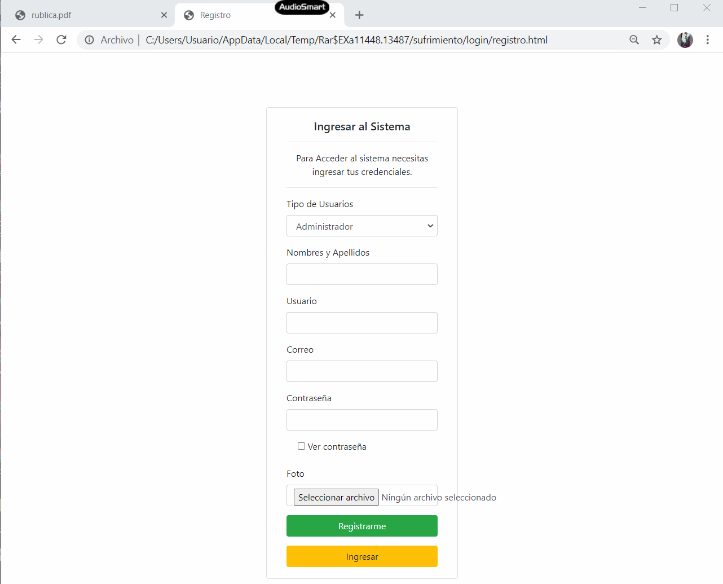

## Evidencia 2(Iniciar Sesión)

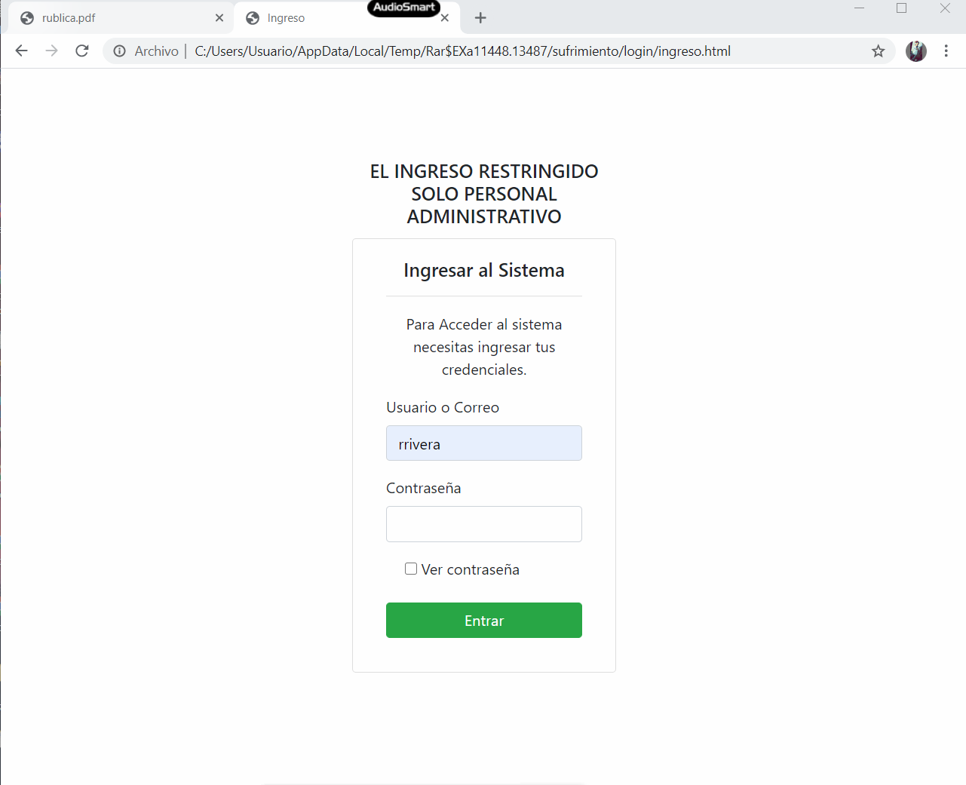

## Evidencia 3(Inicio)

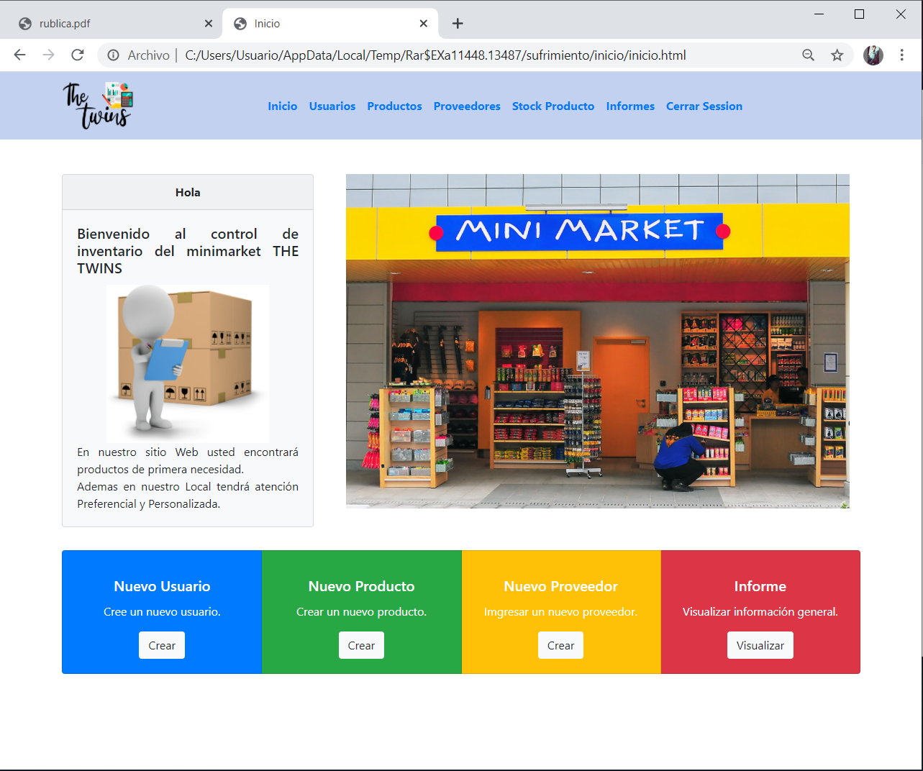

## Evidencia 7(Usuario)

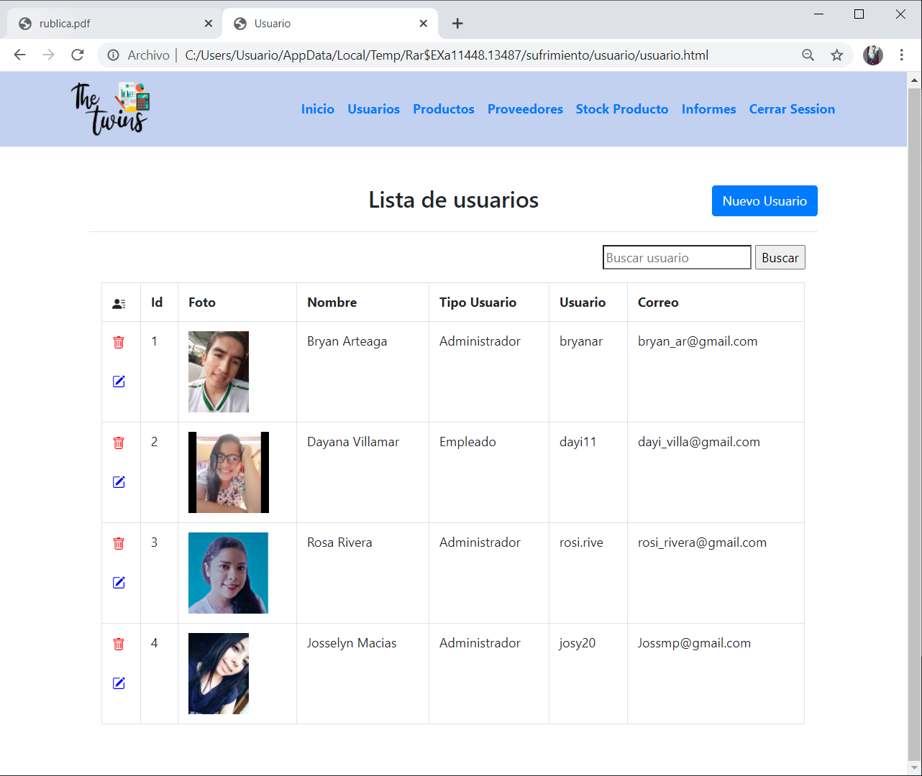

## Evidencia 8(Nuevo usuario)

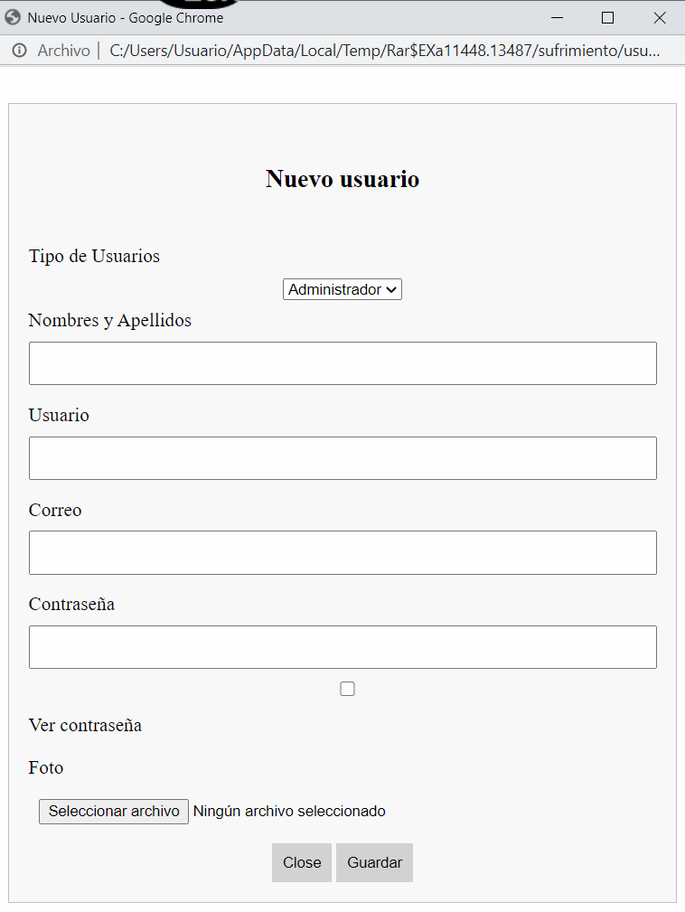

## Evidencia 9(Eliminar usuario)

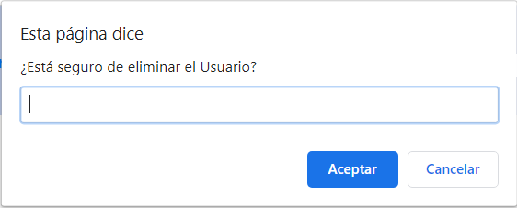

## Evidencia 10(Editar usuario)

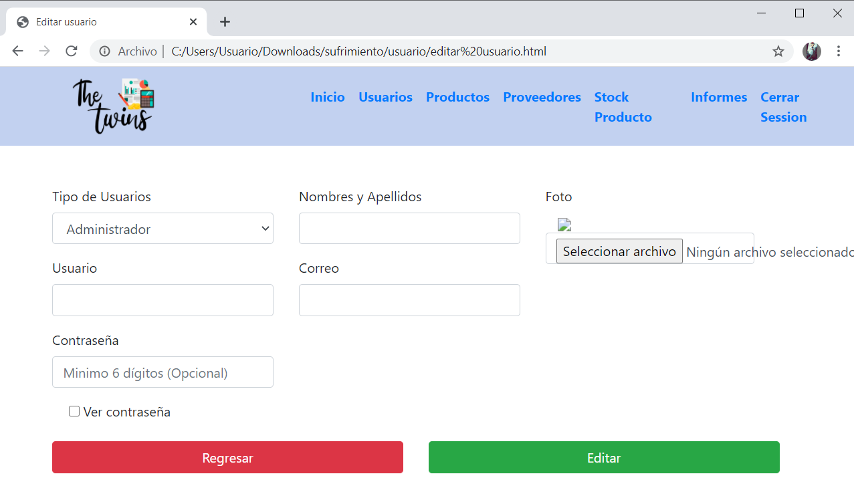

## Evidencia 11(Lista de Productos)

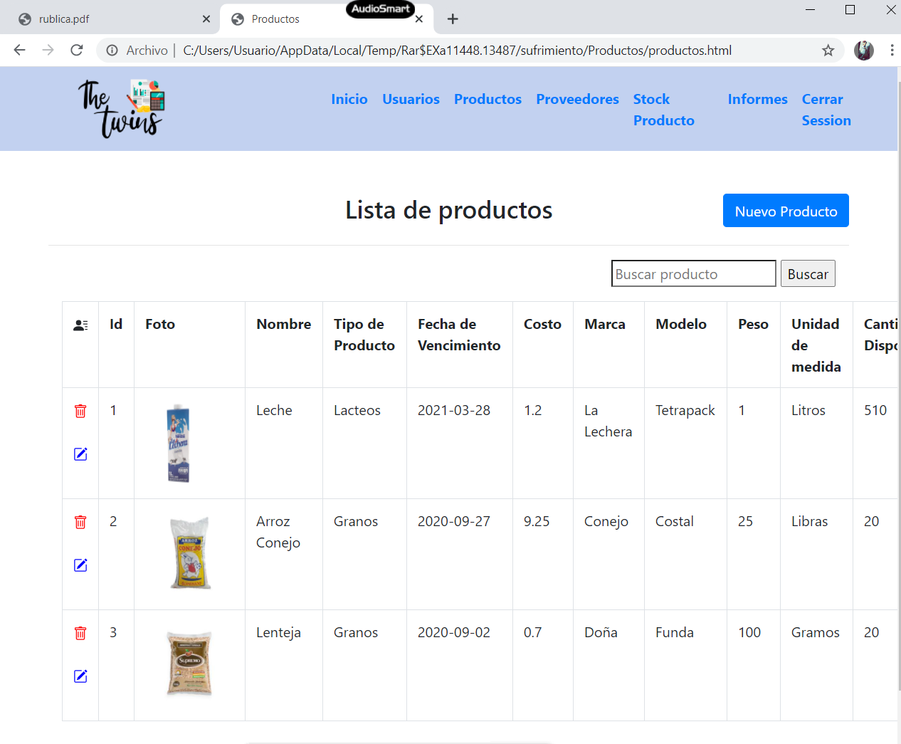

## Evidencia 12(Nuevo Producto)



## Evidencia 13(Eliminar Producto)

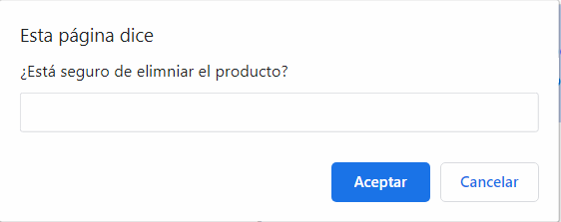

## Evidencia 14(Editar Producto)

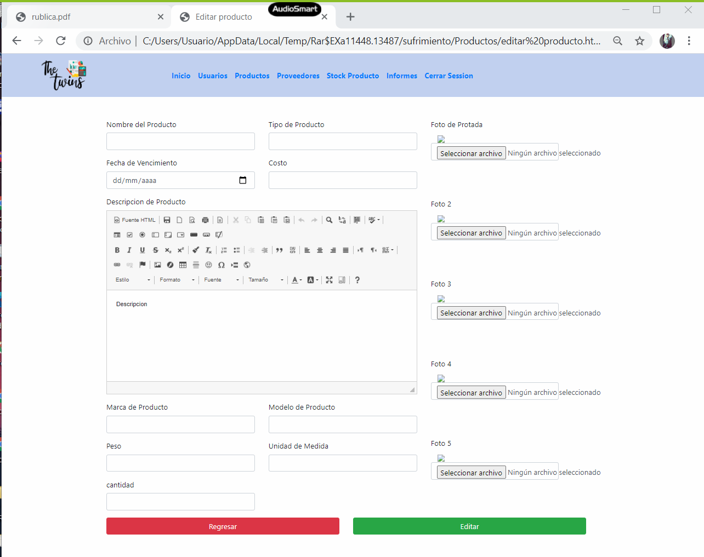

## Evidencia 15(Lista de proveedores)

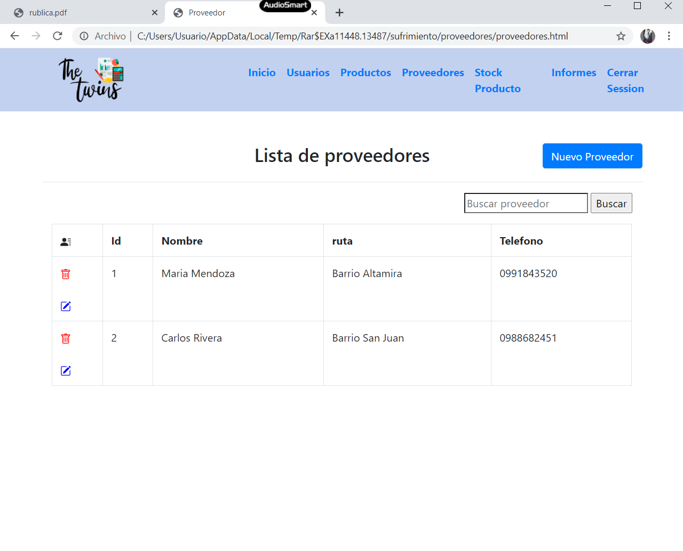

## Evidencia 16(Nuevo Proveedor)

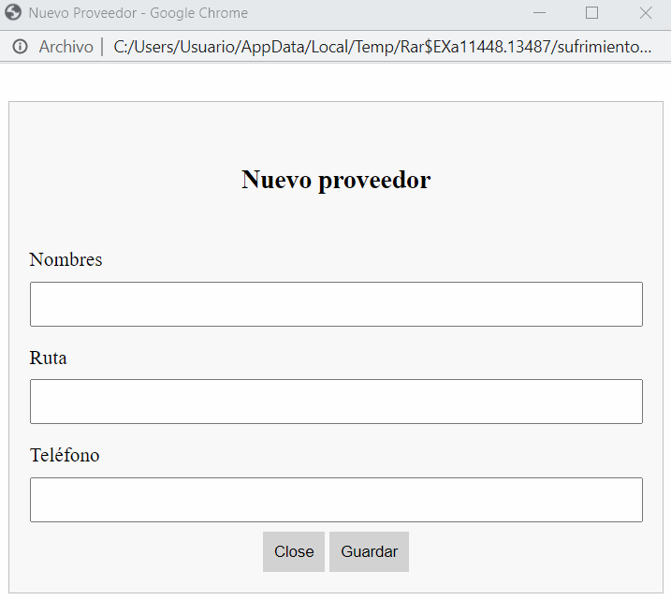

## Evidencia 17(Eliminar Proveedor)

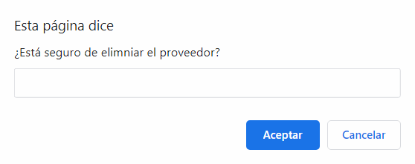

## Evidencia 18(Editar Proveedor)

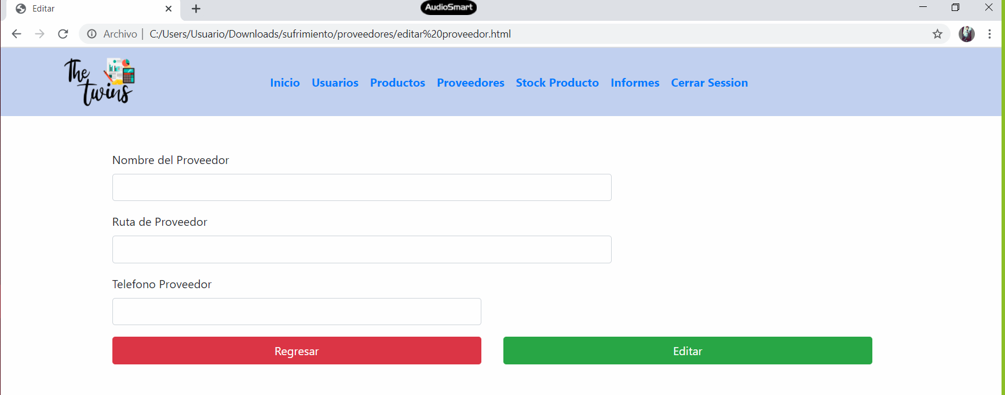

## Evidencia 19(Stock de productos)

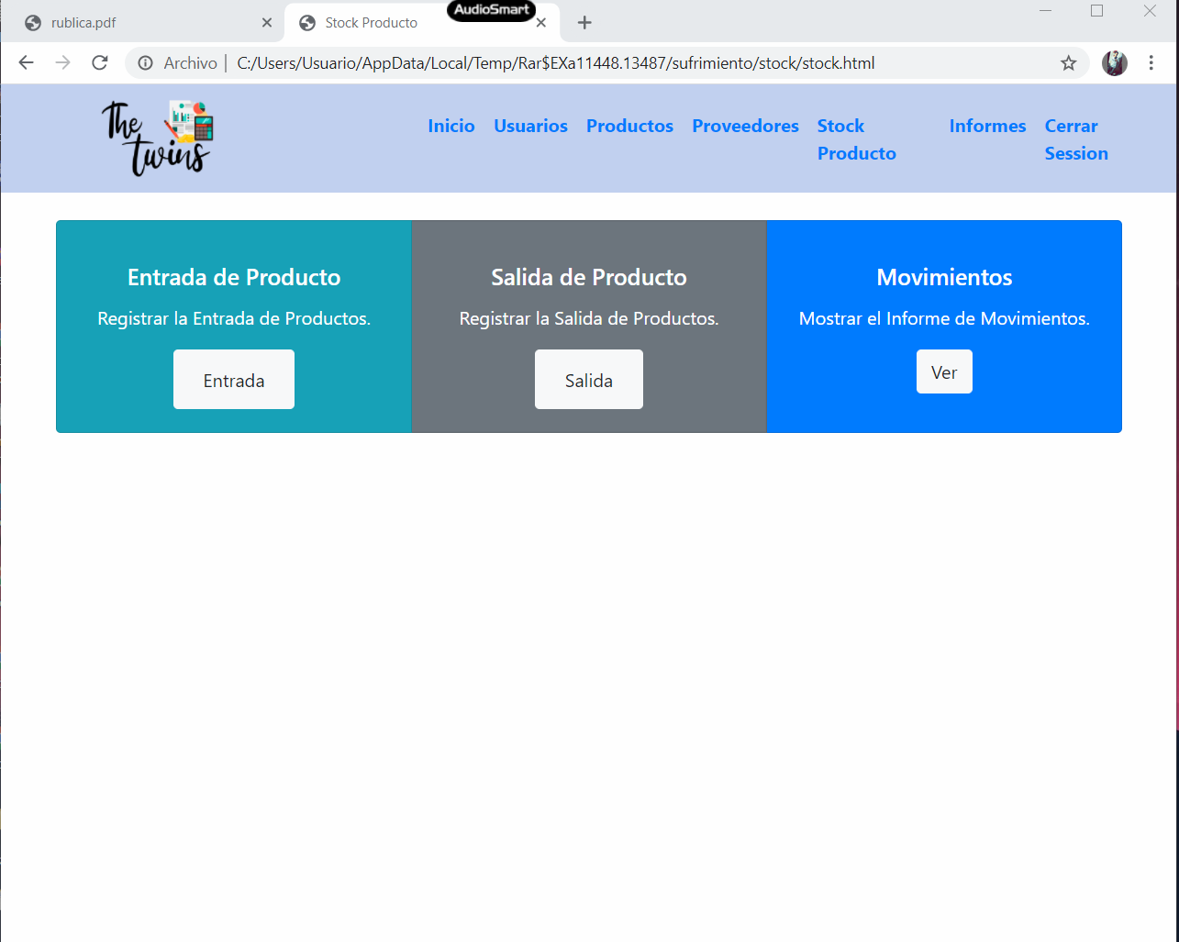

## Evidencia 20(Entrada de producto)

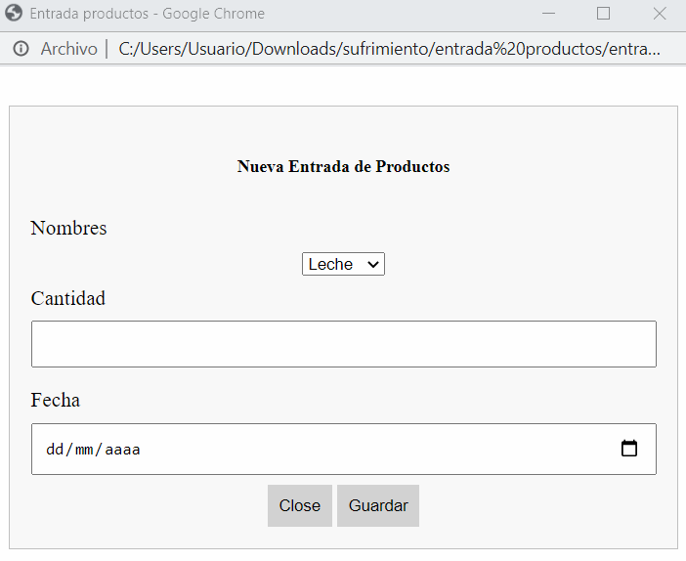

## Evidencia 21(Salida de producto)

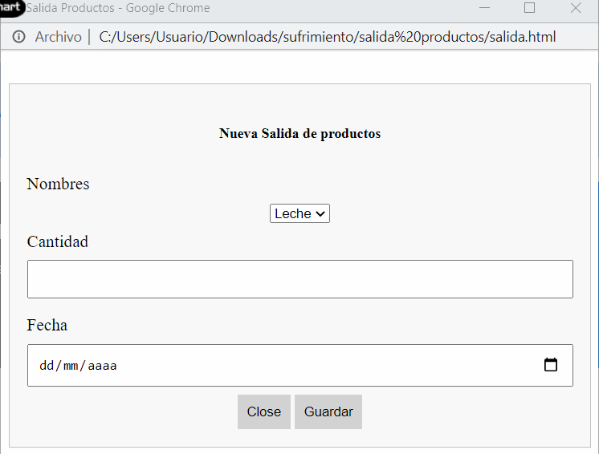

## Evidencia 22(Movimientos: Informe de productos)

